Clerk / Responsible Financial Officer: Mrs Susan Rodaway
EXTRAORDINARY MEETING OF MAWR COMMUNITY COUNCIL (MCC)
Held remotely via Zoom on Friday 7th July 2023 at 7.00 pm.
MINUTES

PRESENT: Cllr. L. Frame (LF), Cllr. C. Williams (CW), Cllr. M. Davies (MD), Cllr. D. James (DJ), Cllr V. Morgan-Beattie (VMB) joined at 8pm.
APOLOGIES: Cllr V. Morgan-Beattie (VMB) for lateness.
Declarations of Interest
None.
Under the Public Bodies (Admission to Meetings) Act 1960, the public and representatives of the press and broadcast media be excluded from the meeting during the consideration of the following items of business as publicity would be prejudicial to the public interest because of the confidential nature of the business to be transacted.
Proposed LF; Seconded DJ; Agreed All.
- 2023/77 To discuss legal matters.
A full and detailed discussion took place, considering evidence provided and the evidence held on file.
VMB arrived during this discussion.
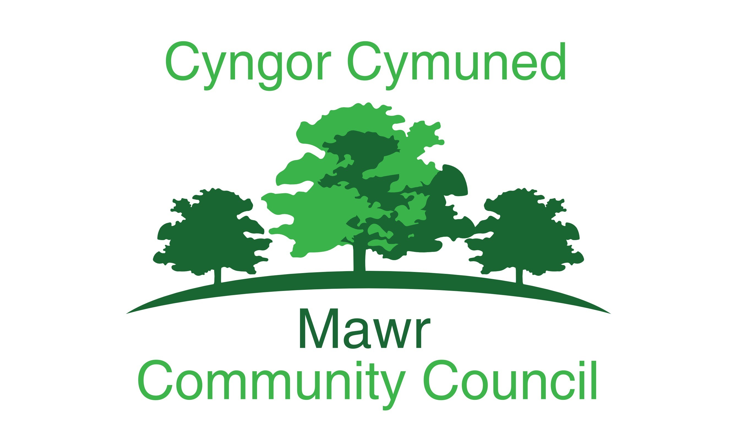
- 2023/78 To agree a way forward regarding legal matters.
To proceed in accordance with ACAS request.
Proposed: MD; Seconded: MD; Agreed by all.
Meeting Closed 20.54

