To: Aelodau o Cyngor Cymuned Mawr/Members of Mawr Community Council.
Members of the Finance, employment and policy committee are summoned to attend a meeting Held remotely via Zoom on Wednesday 19th February 2024 at 7.00pm.
(Press and public are excluded from this meeting)

Under the Public Bodies (Admission to Meetings) Act 1960 S.1 (7), filming and recording of meetings by the press and public is not permitted.
Join Zoom Meeting:
https://us06web.zoom.us/j/7056476463?omn=89622618597

AGENDA

Apologies for Absence
Schedule 12 of the Local Government Act 1972 requires a record to be kept of the members present and that this record form part of the minutes of the meeting. Members who cannot attend a meeting should tender apologies to the Clerk as it is usual for the grounds upon which apologies are tendered also to be recorded.
Declarations of Interest

Under the Public Bodies (Admission to Meetings) Act 1960, the public and representatives of the press and broadcast media be excluded from the meeting during the consideration of the following items of business as publicity would be prejudicial to the public interest because of the confidential nature of the business to be transacted.

- To discuss complaints from members of the public, in accordance with the Council’s complaints procedure, and agree a way forward.

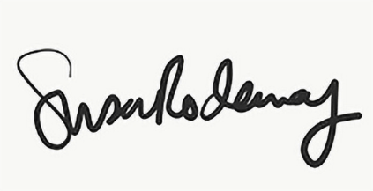

Susan Rodaway
Clerk/RFO
Mawr Community Council
13/06/2024

