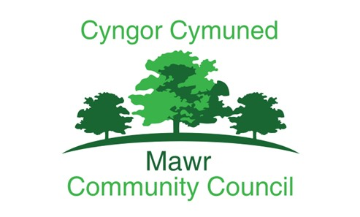

Mawr Community Council
Modern Slavery Policy

Adopted: December 2025
Review Date: AGM 2026

V0.1.

INTRODUCTION
Mawr Community Council supports the implementation of the Modern Slavery Act 2015 and are committed to eliminating practices and conditions which may foster modern slavery to occur.
Mawr Community Council expects its joint venture partnerships, contractors, suppliers, and its staff, falling in scope of this legislation, to be aware of and comply with the requirements of the Act. We are committed to encouraging fair pay and working conditions in our own operations as well as within our wider supply chain and to eliminate modern slavery and human trafficking.
WHAT IS MODERN SLAVERY?
The UK Modern Slavery Act was enacted in 2015 to create more transparency throughout organisational supply chains to uncover modern slavery abuses and human trafficking. Public bodies which have a budget of £36 million or more, including local authorities in England and Wales, will be required to regularly report on the steps they have taken to prevent modern slavery in their supply chains (https://www.legislation.gov.uk/ukpga/2015/30/contents/enacted).
Modern slavery is a serious and often hidden crime in which people are exploited for criminal gain. The impact can be devastating for the victims.
Modern slavery takes many different forms in the UK, including:
− Forced labour; victims are forced to work against their will, often working very long hours for little or no pay in dire conditions under verbal or physical threats of violence.
− Debt bondage: victims are forced to work to pay off debts that realistically they never will be able to.
− Sexual exploitation: victims are forced to perform non-consensual or abusive sexual acts against their will, such as prostitution, escort work and pornography. Adults are coerced often under the threat of force, or another penalty.
− Criminal exploitation: often controlled and maltreated, victims are forced into crimes such as cannabis cultivation or pick pocketing against their will.
− Domestic servitude: victims are forced to carry out housework and domestic chores in private households with little or no pay, restricted movement, very limited or no free time and minimal privacy often sleeping where they work.
− Child trafficking: young people (under 18) are moved internationally or domestically so they can be exploited.
− Organ harvesting; where persons are trafficked in order to sell their body parts and organs for transplants – includes eggs, kidneys and eyes.
OUR COMMITMENT
We want to ensure that all council staff, including those in our family of companies can recognise and call out modern slavery and that we do everything we can to ensure modern slavery is not occurring within our supply chains. We will do this through training and development and open communications.
This Policy commits the Council to work in partnership to support the operational response to modern slavery and collaborate with our family of companies to ensure we are tackling modern slavery together.
The Council will produce a Modern Slavery Statement which will explain the steps that Mawr Community Council took in the previous financial year to identify, prevent and mitigate modern slavery in our operations and supply chains. It will cover the following six areas:
• Organisation structure and supply chains
• Policies in relation to slavery and human trafficking
• Due diligence processes
• Risk assessment and management
• Key performance indicators to measure effectiveness of steps being taken
• Training on modern slavery and trafficking.
OUR PRINCIPLES
The Council has adopted the following overarching set of principles which should be used to help
guide our practice and help inform the action we take.
1. Training and development
The Council will; (1) ensure that all staff working in high-risk service areas are appropriately trained to understand, recognise and call out modern slavery, (2) that training opportunities are provided to our partners working in high-risk roles and (3) continue to work with partners to develop responses in line with the need of victims.
2. Referrals
The Council will continually re-enforce through appropriate communications the referral mechanisms for staff, suppliers and communities for reporting any concerns around modern slavery.
3. Procurement
The Council will take account of ethical and modern slavery considerations in our procurement processes and our contractual arrangements, requiring its contractors to comply fully with the Modern Slavery Act 2015, wherever it applies.
4. Whistleblowing
The Council will support its staff to blow the whistle on any suspected examples of modern slavery and will require its tendered contractors to adopt a whistle-blowing policy.
5. Openness and transparency
The Council will, with involvement from its partners, report publicly and be open and honest about its progress in tackling modern slavery.
6. Collaboration
The Council will work extensively with partner organisation, including the Police to identify and tackle modern slavery in the city and will take enforcement action where necessary.
This Policy should be read in conjunction with Mawr Community Council’s documents:
• Equality and Diversity Policy
• Whistleblowing policy

