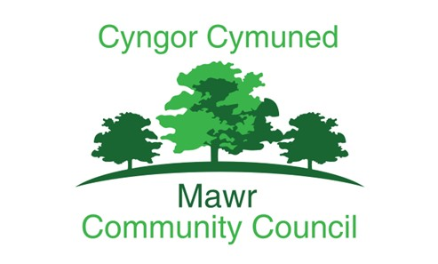

Mawr Community Council
Anti Money Laundering Policy

Adopted: December 2025
Review Date: AGM 2026

V0.1.

Mawr Community Council is committed to preventing the use of its activities, systems, and functions for money laundering, terrorist financing and related financial wrongdoing.
While community councils are generally low risk, this policy sets out our responsibilities under UK law, supports good governance and financial control, and explains how the Council will identify and respond to suspicious activity.

The purpose of this policy is to:
- Protect the Council from being used to facilitate money laundering.
- Set out procedures for identifying and reporting suspicious activity.
- Ensure compliance with relevant legislation, including:
  - Proceeds of Crime Act 2002 (POCA)
  - Money Laundering Regulations 2017 (as amended)
  - Terrorism Act 2000
  - Terrorist Asset Freezing etc. Act 2010
This policy applies to all councillors, employees, volunteers, contractors and any person acting on behalf of the Council.
It covers all financial activities of the Council, including:
- Receipt of grants, donations, contributions and hall hire income
- Payments to contractors and suppliers
- Banking, payroll and cash handling
- Financial reporting

Definitions
Money Laundering:
The process by which criminals attempt to disguise the original ownership and control of the proceeds of criminal conduct by making such proceeds appear to have derived from a legitimate source.
Criminal Property:
Any property that the Council knows or suspects is derived from criminal activity.

Legal Framework
Councils may not be regulated entities like banks, but the following key laws and obligations apply:
- Proceeds of Crime Act 2002 (POCA) — makes it an offence to handle the proceeds of crime.
- Money Laundering Regulations 2017 (as amended) — emphasise risk assessment and internal controls for organisations.
- Terrorism Act 2000 & Terrorist Asset Freezing etc. Act 2010 — cover terrorist financing.
The Council must not knowingly accept, handle or facilitate criminal property or funds derived from criminal activity.

Roles & Responsibilities
Councillors must:
- Understand the policy and act in accordance with it.
- Exercise vigilance over financial matters affecting the Council.
- Report any suspicions to the Responsible Officer.
The Clerk (or Responsible Officer) is designated to:
- Oversee AML compliance and risk assessment.
- Maintain appropriate records.
- Receive and assess reports of suspicious activity.
- Make reports to the appropriate authorities if required.

Risk Assessment
Although the Council is low risk, it will assess potential exposure to money laundering through:
- High-value cash payments
- Unusual or unverifiable sources of income
- Anonymous or third-party payments
- Grants, donations or contributions with unclear origins
- Activities outside normal council operations
Any unusual patterns should be flagged for review.

Customer Due Diligence (CDD)
Due diligence is required when the Council:
- Accepts unusual or large cash payments
- Receives donations or funds from unfamiliar sources
- Receives grants from individuals or organisations without clear identity
CDD measures may include:
- Requesting identification for individuals offering funds
- Verifying organisational legitimacy for groups, companies, charities
- Recording the source and reason for the funds
CDD documentation must be retained by the Clerk.

Suspicious Activity Reporting
Report any suspicion of:
- Concealment of criminal property
- Attempted influence on council financial decisions by unknown sources
- Funds with no identifiable origin
- Unusual patterns of transactions
All concerns should be reported immediately to the Clerk/Responsible Officer. If the concern involves the Clerk, the Chair must be informed.
A written record must be kept, including:
- Date and time
- Nature of suspicion
- People involved
- Supporting documentation
If reasonably suspected that criminal property is involved, the Clerk (or Chair if the Clerk is involved) must consider reporting to:
- The National Crime Agency (NCA) via a Suspicious Activity Report (SAR), or
- Local law enforcement
Legal advice may be sought before making an SAR.

Internal Controls
The Council will maintain internal controls to protect against money laundering, including:
- Segregation of duties where practical
- Bank reconciliation and dual signatories
- Accurate and timely financial records
- Clear documentation for income and expenditure
- Regular review by internal/external auditors

Record-Keeping
Records to be maintained for at least five years:
- Payment receipts
- Bank statements
- Supporting invoices and purchase orders
- Due diligence documents
- Minutes related to financial decisions
- Reports of suspicious activity
Retention will be in accordance with the Council’s document retention policy.

Training & Awareness
The Council will:
- Provide basic AML awareness guidance to councillors and staff.
- Review training needs at least annually.
- Ensure that officers can recognise and report suspicious activity.

