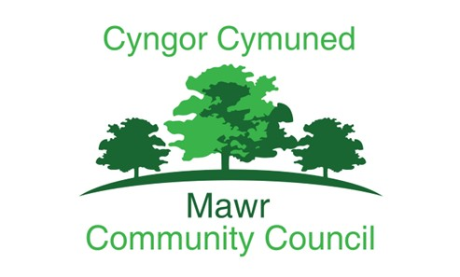

Mawr Community Council
Grant Aid Policy

Adopted: December 2025
Review Date: AGM 2026

V0.1.

The Community Council Grant Scheme is made available through Section 137 of the Local Government Act 1972. Section 137 states that any financial assistance awarded must bring direct benefit to a local authority’s area or any part of it or some of its inhabitants.

Grants will not be given to individuals or commercial organisations.

Grants applications will be considered on a case by case and meeting to meeting basis.

Grant applications must be made on the official application form. Applicants must set out how the community in the Community Council area will benefit from the work funded by any grant. This is particularly important where an application is made by an organisation working regionally or nationally.

Applications must be accompanied by a copy of the organisation’s most recent balance sheet.

Grant recipients receiving over £1,000 should submit a report after 31 March showing how the funding has been used.

PRINCIPLES OF COMMUNITY GRANTS
The system aims to:
- Help the wards voluntary groups to improve their effectiveness
- Help to ensure the provision of services needed by the residents via the voluntary sector
- Support organisations which meet the needs of people experiencing social and economic difficulties and
- Ensures that there is equality of access and opportunity for all residents to the services and funds it provides to increase community inclusion.
The Community Council values the diversity and strengths of the local voluntary sector and acknowledges its independent role in the community as:
- A source of valuable services
- A means of enabling people to work together
- A channel for campaigning and advocacy
- To reduce loneliness in all ages in our community
The Community Council defines a voluntary group as a ‘not-for-profit’ organisation, set up and run by a voluntary, management committee.

This document gives the Community Council’s general funding principles and details its expectations of all groups in receipt of a Community Grant.

GROUPS APPLYING FOR A COMMUNITY GRANT AID SHOULD NOTE:
- Grants are restricted by law to applications made by groups only and on matters that benefit a majority of ward residents.
- Grants are made to meet deficits on future running costs, to encourage new groups or new projects, or to help with the costs of some one-off expenditures
- Grants will only be made to groups which need financial help. Accumulated reserves will be considered when grant levels are decided.
- Grants are made for one year’s expenditure at a time and should be spent within the year for the purpose for which they were given. They should not be added, wholly or partly, to reserves unless part of a previously approved programme of funding for a particular project.
- Grants will not be made to groups, which operate for private gain.
- Organizations may be required to return the Community grant or a percentage of it, if they cease to function during the 12 months following allocation of the grant.

VOLUNTARY GROUPS RECEIVING A GRANT FROM THE COUNCIL ARE REQUIRED TO:

- Ensure efficient levels of administration, hold regular meetings, keep minutes and circulate information to group members.
- Keep proper accounts. Grants may only be made to groups, which have submitted satisfactory accounts, unless the group is recently formed.
- Report back as required to the Council on their activities
- Involve group members and users in policy-making and in the management of activities and services
- Be open to eligible users, as defined by the group’s constitution
- Establish and monitor equal opportunities policies and practices
- Meet the legal responsibilities of an employer where appropriate; adopt, implement and monitor good employment practices and procedures
- Recruit and support volunteers where appropriate
- Acknowledge the Community Council’s support in annual reports.

