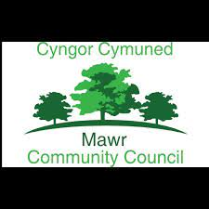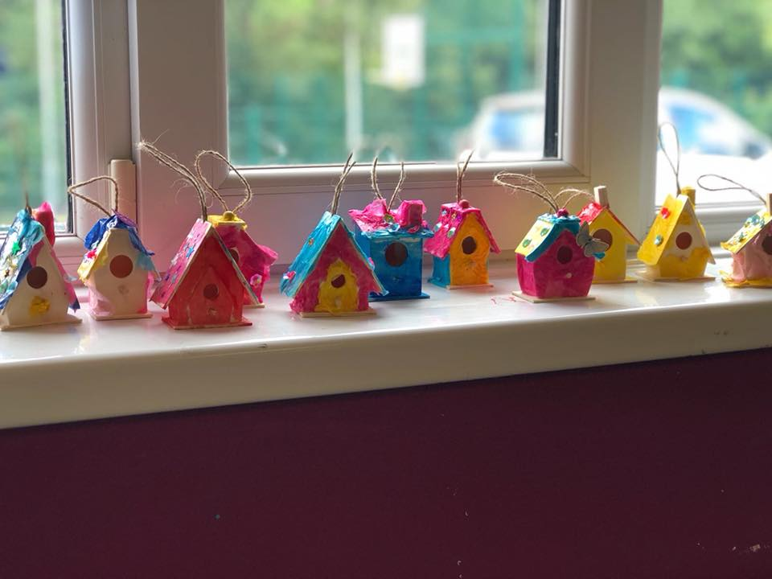

**Mawr Summer Activities Club**

**2022**



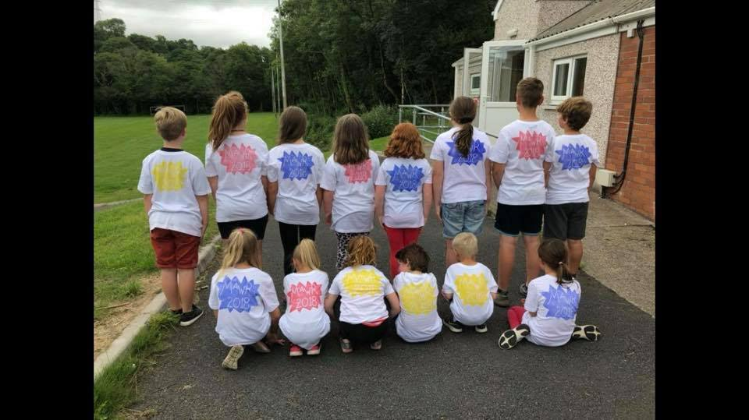

£2 per day

For children 5-14 years old

Wide range of activities, crafts and sports, outdoor and indoor games

plus much more!

**Sessions Run from: 10 am - 2 pm each day**

**25th – 29th July – Craig Cefn Parc Welfare Hall**

**1st – 5th August – Felindre Welfare Hall**

**8th - 12th August – Garnswllt Welfare Hall**

**To book a place contact** [**danielledavies99@gmail.com**](mailto:danielledavies99@gmail.com)

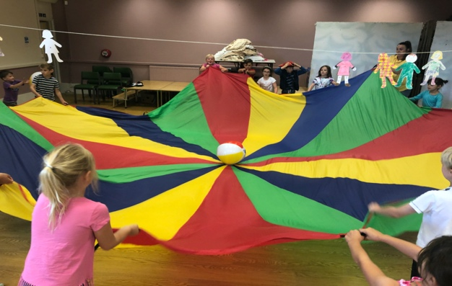

**Guidelines:**

**All children must bring their own water bottle and lunch with their name clearly marked.**

**Children should stay home if unwell.**

**Please register your children by emailing**

[**danielledavies99@gmail.com**](mailto:danielledavies99@gmail.com)

**Registration forms can be completed on arrival. Please note that spaces are limited.**



**Grant funded by City and County of Swansea Children and Young People Fund**