**Registrations forms must be completed before attending. For more information or registration forms please contact Danielledavies99@gmail.com , or download a registration form from our website mawrcommunitycouncil.org.uk**



**Play Sessions will run from 10am – 2pm**

**30th July – 3rd Aug -Felindre Welfare Hall**

**6th Aug – 10th Aug - Craig Cefn Parc Hall**

**13th Aug – 17th Aug - Garnswllt Welfare Hall**

Wide range of daily activities, including arts and crafts, sports, outdoor and indoor games and much more!

ONLY £2 per day!

Please bring a packed lunch

Children must be over 5 years old ages 3 & 4 must be accompanied by an adult

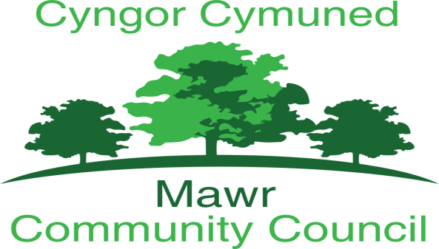

Supported by:

