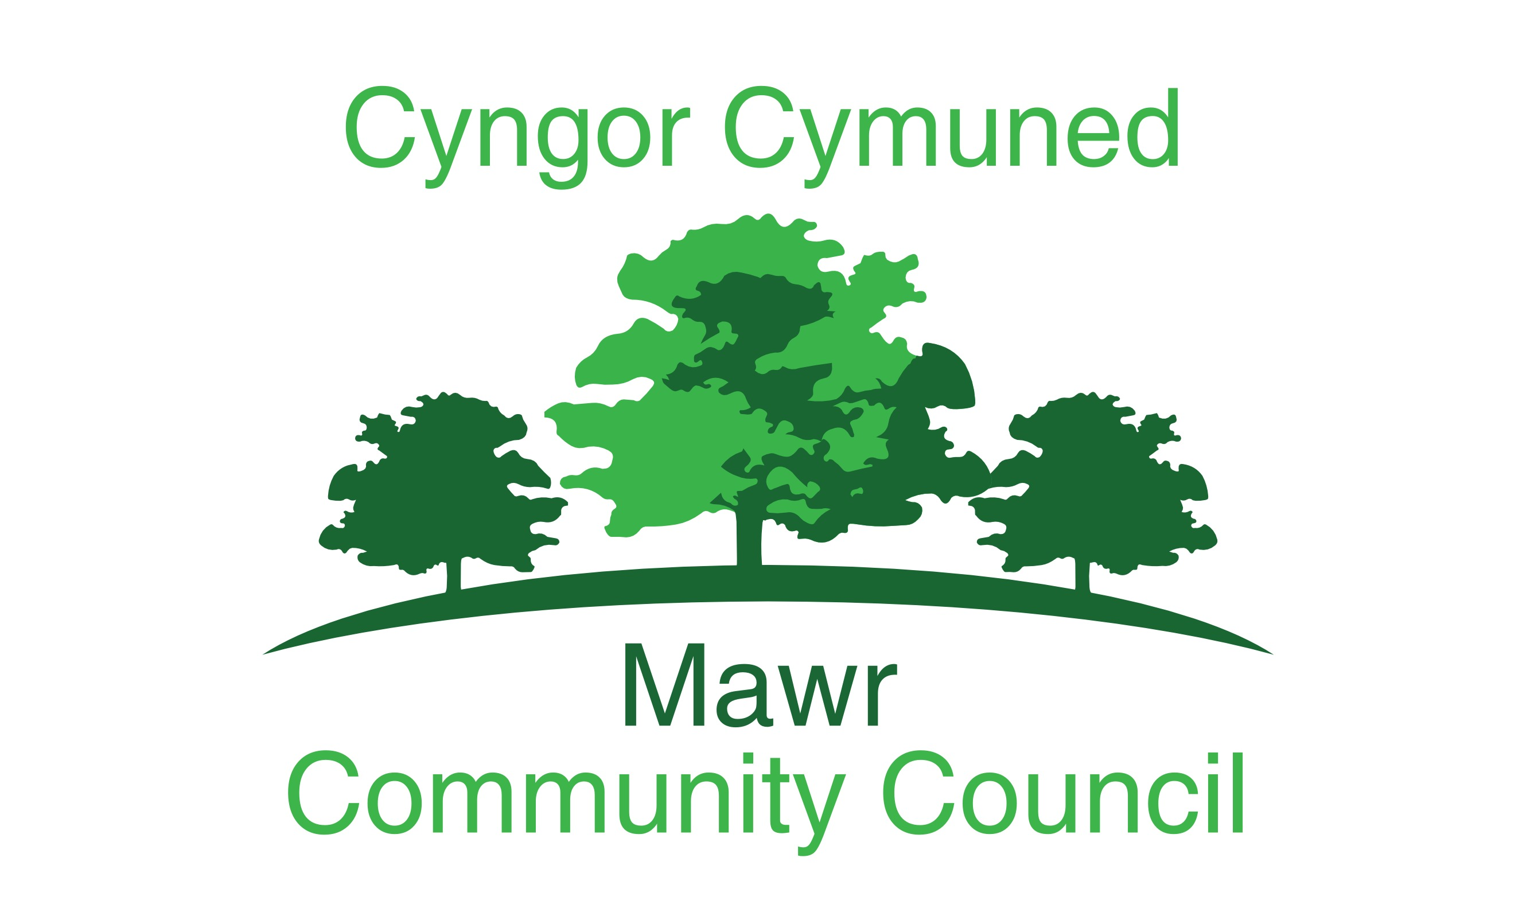
49 Awel Y Mor
Sketty, Swansea, SA2 9FL
clerk@mawrcommunitycouncil.cymru 07730 527745

Councillors are summoned to attend the online AGM of
Mawr Community Council
at 6:30pm on 10 May 2021 via Microsoft Teams
Even though the Community Council meetings are being held remotely via Microsoft Teams, members of the press and public are entitled to attend. Anyone wishing to attend should contact the Clerk via email by Friday prior to the date of the meeting to obtain the appropriate link.
The order of business shall be as follows:

- The election of the Chairperson of the Council for 2021/22

- The election of the Vice-Chairperson of the Council for 2021/22

- Apologies for absence

- Declarations of Interest

- The business of the annual meeting shall include:

    - Signing by the Chairperson, Vice Chairperson and Councillors of their acceptance of office forms
    - Confirmation of the accuracy of the minutes of the last AGM of the council;
    - Receipt of the minutes of the last meeting of a committee;
Personnel Committee
    - Consideration of the recommendations made by a committee;
None
    - Review of delegation arrangements to committees, sub-committees, staff and other local authorities;
    - Review of the terms of reference for committees;
    - Appointment of members to existing committees;
    - Appointment of any new committees in accordance with standing order 4 above;
    - Review and adoption of appropriate standing orders and financial regulations;
    - Review of arrangements, including any charters and agency agreements, with other local authorities and review of contributions made to expenditure incurred by other local authorities;
    - Review of representation on or work with external bodies and arrangements for reporting back;
    - Review of inventory of land and assets including buildings and office equipment;
    - Confirmation of arrangements for insurance cover in respect of all insured risks;
    - Review of the council’s and/or staff subscriptions to other bodies;

That this Council subscribe to the SLCC and One Voice Wales for the Clerks assistance and information in running this council.

    - Review of the council’s complaints procedure;
    - Review of the council’s procedures for handling requests made under the Freedom of Information Act 2000 and the Data Protection Act 1998;
    - Review of the council’s policy for dealing with the press/media; and
    - Determining the time and place of ordinary meetings of the full council up to and including the next Annual General Meeting of full council.

Suggested Dates:
14 June 2021
12 July 2021
13 Sept 2021
11 Oct 2021
08 Nov 2021
13 Dec 2021
10 Jan 2022
14 Feb 2022
14 March 2022
12 May/19 May 2022

    - To discuss Charitable Donations.
    - To appoint a representative for One Voice Wales.
    - To re-appoint the Internal Auditor.

Geraint Thomas
Temporary Clerk to the Council

