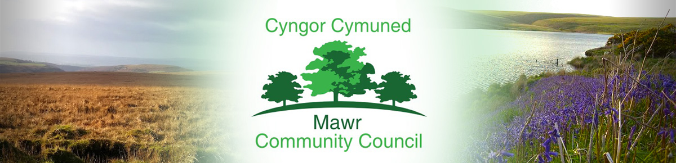

Ms. M. L. Gabriel – Davies,Clerk / Responsible Financial Officer
C/O Penmount,150 Alexandra Road, Gorseinon, Swansea SA4 4PE
Telephone; 01792 896789
email: clerk.rfo@mawrcommunitycouncil.cymru
www.mawrcommunitycouncil.org.uk

Councillors are summoned to attend a meeting of the Mawr Community Council held remotely via Zoom Monday 21st February 2022 at 7.00pm.

Even though the Community Council meetings are being held remotely at present via Zoom, members of the press and public are entitled to attend. Anyone wishing to attend should contact the Clerk via email by Friday prior to the date of the meeting to obtain the appropriate link.
The order of business shall be as follows:

- Apologies for absence

- Declarations of Interest

- Public Forum –

- Report on Status of Grants – Biodiversity Project, etc.

- Report from the Swansea City County Councillor

- Confirmation of the accuracy of the minutes from the last meeting held on 10 January 2022

- Matters arising from the minutes - Clerk to update/advise

- Confirmation of Precept requirement 2022/23

- Halls update: Garnswllt Hall – Temporary Clerk/Cllr Tom Roberts
Felindre Welfare Hall – Cllr Paul Northcote
CCP Welfare Hall – Cllr L Frame

- May 2022 Elections and Administrative Issues

- Reports from committees, sub committees and working parties

- Report from the Chairperson

- Clerk’s General Report: Update on matters of relevance

- Report from the Community Councillors

- To consider planning applications: (already circulated)

- Correspondence

- Financial Reports - To receive outstanding Financial Reports

- Staff Matters - This section is confidential and is therefore closed to the public as agreed in full council

- Date and time of next meeting

M. L. Gabriel – Davies, Clerk and Responsible Financial Officer

