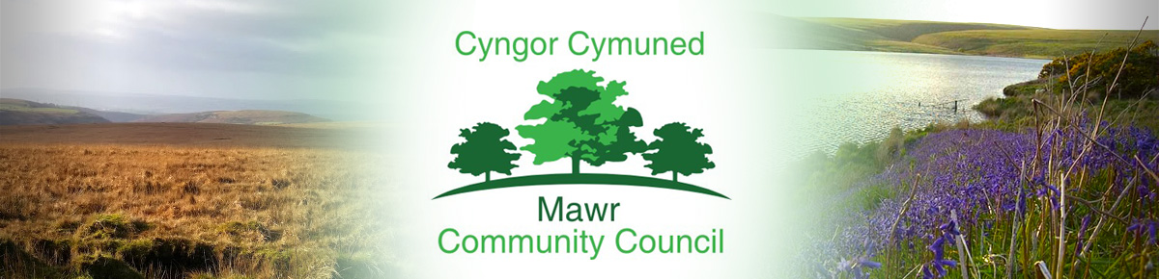

Clerk / Responsible Financial Officer: Ms. M. L. Gabriel – Davies
C/O Penmount,150 Alexandra Road, Gorseinon, Swansea SA4 4PE
Telephone: 07368 652254 E-mail: clerk.rfo@mawrcommunitycouncil.cymru
www.mawrcommunitycouncil.org.uk

Councillors are summoned to attend a meeting of the Mawr Community Council held remotely via Zoom Monday 16th May 2022 at 7.00pm.

Even though the Community Council meetings are being held remotely at present via Zoom, members of the press and public are entitled to attend. Anyone wishing to attend should contact the Clerk via email by Friday prior to the date of the meeting to obtain the appropriate link.
The order of business shall be as follows:

- Apologies for absence

- Declarations of Interest

- Public Forum

- Project Coordinator’s Report on Biodiversity

- County Councillors – introduction of newly-elected county councillors

- Confirm the accuracy of the minutes from the last meeting held on 14 March 2022

- Matters arising from the minutes - Clerk to update/advise

- Public Notice for Co-option of Community Councillors

- Summer Holiday Clubs 2022

- Participatory Budget

- Queen’s Platinum Jubilee Celebrations

- Halls update: Garnswllt Hall – Cllr Tom Roberts/ Cllr Ian Price
Felindre Welfare Hall – Clerk
CCP Welfare Hall – Cllr L Frame

- Clerk’s General Report: a) Grants b) Newsletter/Social Media

- To consider planning applications: (already circulated)

- Correspondence: already circulated

- Financial Reports – 2021-2022 Financial Year Returns and Audit

- Staff Matters - This section is confidential and is therefore, closed to the public as agreed in full council meeting

- Date and time of next meeting

M. L. Gabriel – Davies, Clerk and Responsible Financial Officer

