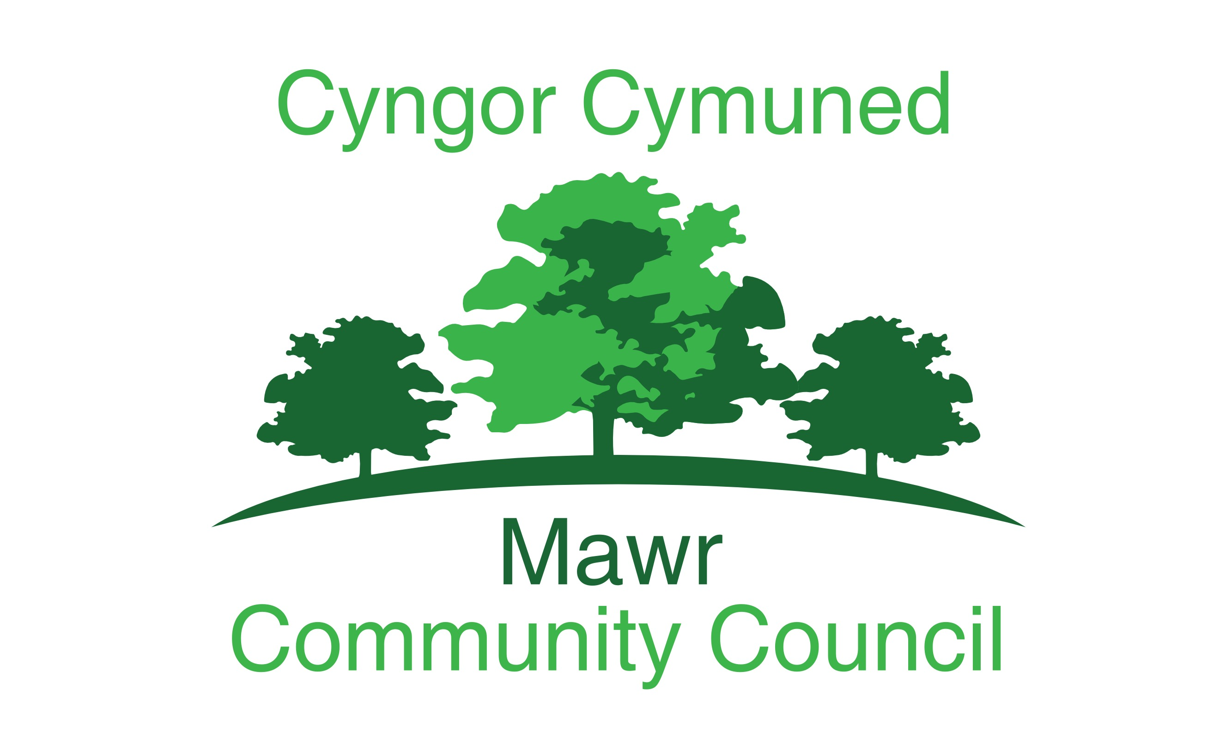
Clerk/RFO: M. L. Gabriel-Davies
clerk.rfo@mawrcommunitycouncil.cymru
www.mawrcommunitycouncil.org.uk
07368 652254
AGENDA

Annual General Meeting of Mawr Community Council
Date: 16 May 2022
Time: 6:30 p.m.
Via Zoom – please contact the clerk by Friday, 13th May to obtain the Zoom meeting link.

Order of business:

- Election of Chairperson for 2022/2023

- Election of Vice Chair for 2022/2023

- Apologies for absence

- Declarations of Interest

- Business of the AGM:

- Signing by Chairperson, Vice Chairperson and Councilors of their acceptance of office forms, due to being “online” this to be completed at a later date.
- Confirmation of Accuracy of the minutes of the last AGM of the council.
- Receipt of the Minutes for the last meeting of the Finance and Employment committee.
- Considerations of the recommendations made by a committee.
- Review of delegation arrangements to committees, sub-committees, staff and local authorities.
- Review of terms of reference for Committees.
- Appointment of members for committees.
- Appointment of New committees in accordance with standing order 4.
- Review and adoption of appropriate standing orders and
financial regulations.
- Review of arrangements, including any charters and agency agreements, with local authorities and review of contributions made to the expenditure incurred by local authorities.
- Review of representations on or work with external bodies
and arrangements for reporting back.
- Review of inventory of land and assets including buildings
and office equipment.
- Review of Council’s and/or staff subscriptions to other Bodies.
- Review of council’s complaints procedure.
- Review of Councils procedure for handling requests made under the Freedom of Information Act 2000 and the Data Protection Act 1998.
- Review the Councils policy for dealing with the Press/media etc.
- Determining the time and place of ordinary meetings of the full council up to and including the next AGM of the Full council.
Suggested Dates:
13 June 2022
11 July 2022
August - no meeting
12 September 2022
10 October 2022
14 November 2022
12 December 2022
09 January 2023
13 February 2023
13 March 2023
10 April 2023
15 May 2023 AGM and Full Council Meeting
All dates subject to confirmation at the preceding meeting.

- To discuss Charitable Donations.
- To appoint a representative for One Voice Wales.
- To re-appoint the Internal Auditor.

