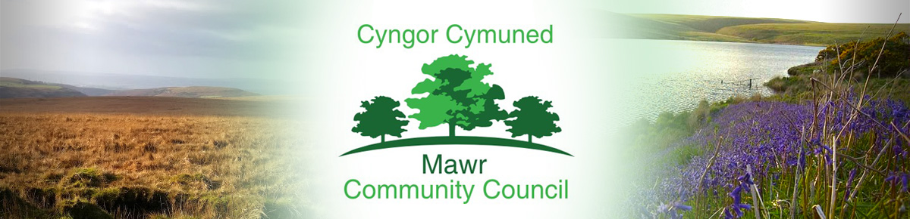

Ms. M. L. Gabriel – Davies,Clerk / Responsible Financial Officer
C/O Penmount,150 Alexandra Road, Gorseinon, Swansea SA4 4PE
Telephone: 07368 652254 E-mail: clerk.rfo@mawrcommunitycouncil.cymru
www.mawrcommunitycouncil.org.uk

Councillors are summoned to attend an extraordinary meeting of the Mawr Community Council to be held remotely via Zoom on Friday, 24th June 2022 at 7.00pm.

The order of business shall be as follows:

- Apologies for absence

- Declarations of Interest

- To finalize the process of Councilor Co-options

M. L. Gabriel – Davies, Clerk and Responsible Financial Officer

This meeting is closed to members of the press and public as agreed in full council meeting

