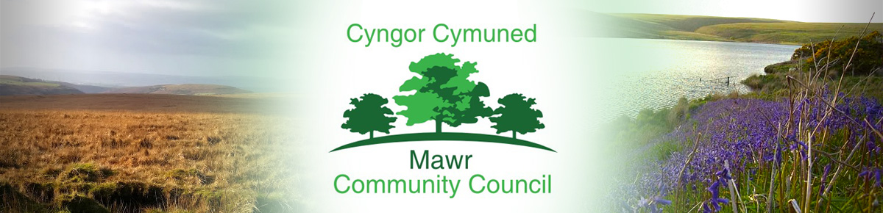
Clerk / Responsible Financial Officer: Ms. M. L. Gabriel – Davies
c/o Penmount,150 Alexandra Road, Gorseinon, Swansea SA4 4PE
Telephone: 07305007575 E-mail: officer@mawrcommunitycouncil.cymru
www.mawrcommunitycouncil.org.uk

Councillors are summoned to attend a meeting of Mawr Community Council on
Monday, 13 February 2023 at 7.00pm
This will be a hybrid meeting held via Zoom and at Felindre Hall.
To obtain the appropriate Zoom link please contact the Clerk via email by noon on Friday prior to the date of the meeting.
The order of business shall be as follows:

- Apologies for absence

- Declarations of Interest

- Confirm the accuracy of the minutes from the last meeting held on 9 January 2023

- Matters arising from the minutes - Clerk to update/advise

- Public Forum – Shall not exceed 10 minutes in total. Members of the public are required to give the Clerk/RFO written notice of the representations they intend to make before 12 noon on the day of the meeting.

- Clerk’s General Report: Update on Grants/Projects/Initiatives

- Chair’s Report

- Receive reports from Community Councillors

- Receive reports from Committees

- Receive reports from County Councillors

- Halls update: Garnswllt Hall –Cllr L Frame/ Cllr G Price
Felindre Welfare Hall – Cllr C Williams/ S. Morgan
CCP Welfare Hall – Cllr L Frame
- Participatory Budget

- Receive Financial Report from Clerk and approve expenditure

- Consider and approve a donation to Cancer Research UK in memory of former Councillor Tom Roberts

- To consider the need for signage

- To consider arrangements for celebrating the Coronation of King Charles III and the advice from Zurich Insurance

- Consider planning applications (already circulated)

- Correspondence (already circulated)

- Confirm date and time of next meeting

- Staff Matters - This section is confidential and is, therefore, closed to the public as agreed in full council meeting

M. L. Gabriel – Davies,
Clerk and Responsible Financial Officer

