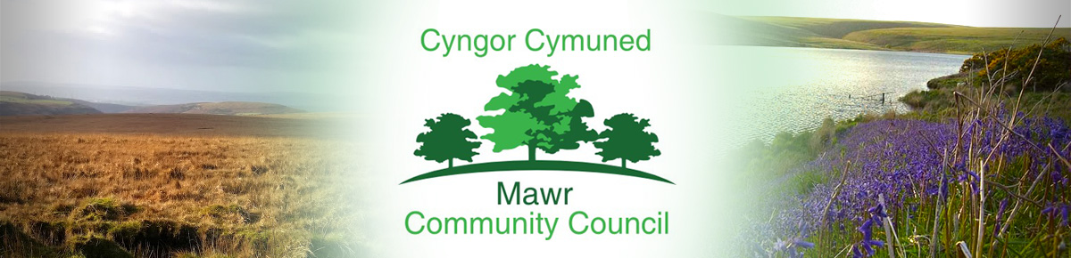

Clerk / Responsible Financial Officer: Ms. M. L. Gabriel – Davies
c/o Penmount,150 Alexandra Road, Gorseinon, Swansea SA4 4PE
Telephone: 07305007575 E-mail: officer@mawrcommunitycouncil.cymru
www.mawrcommunitycouncil.org.uk

Councillors are summoned to attend an extraordinary meeting of Mawr Community Council
to be held on Monday, 6 February 2023 at 7:30 p.m. via Zoom

The order of business shall be as follows:

- To receive apologies for absence

- To receive declarations of Interest

- To ratify the appointment of the Clerk/Responsible Finance Officer

- To consider staff matters

M. L. Gabriel – Davies, Clerk and Responsible Financial Officer

This meeting is closed to members of the press and public as agreed in full council meeting.

