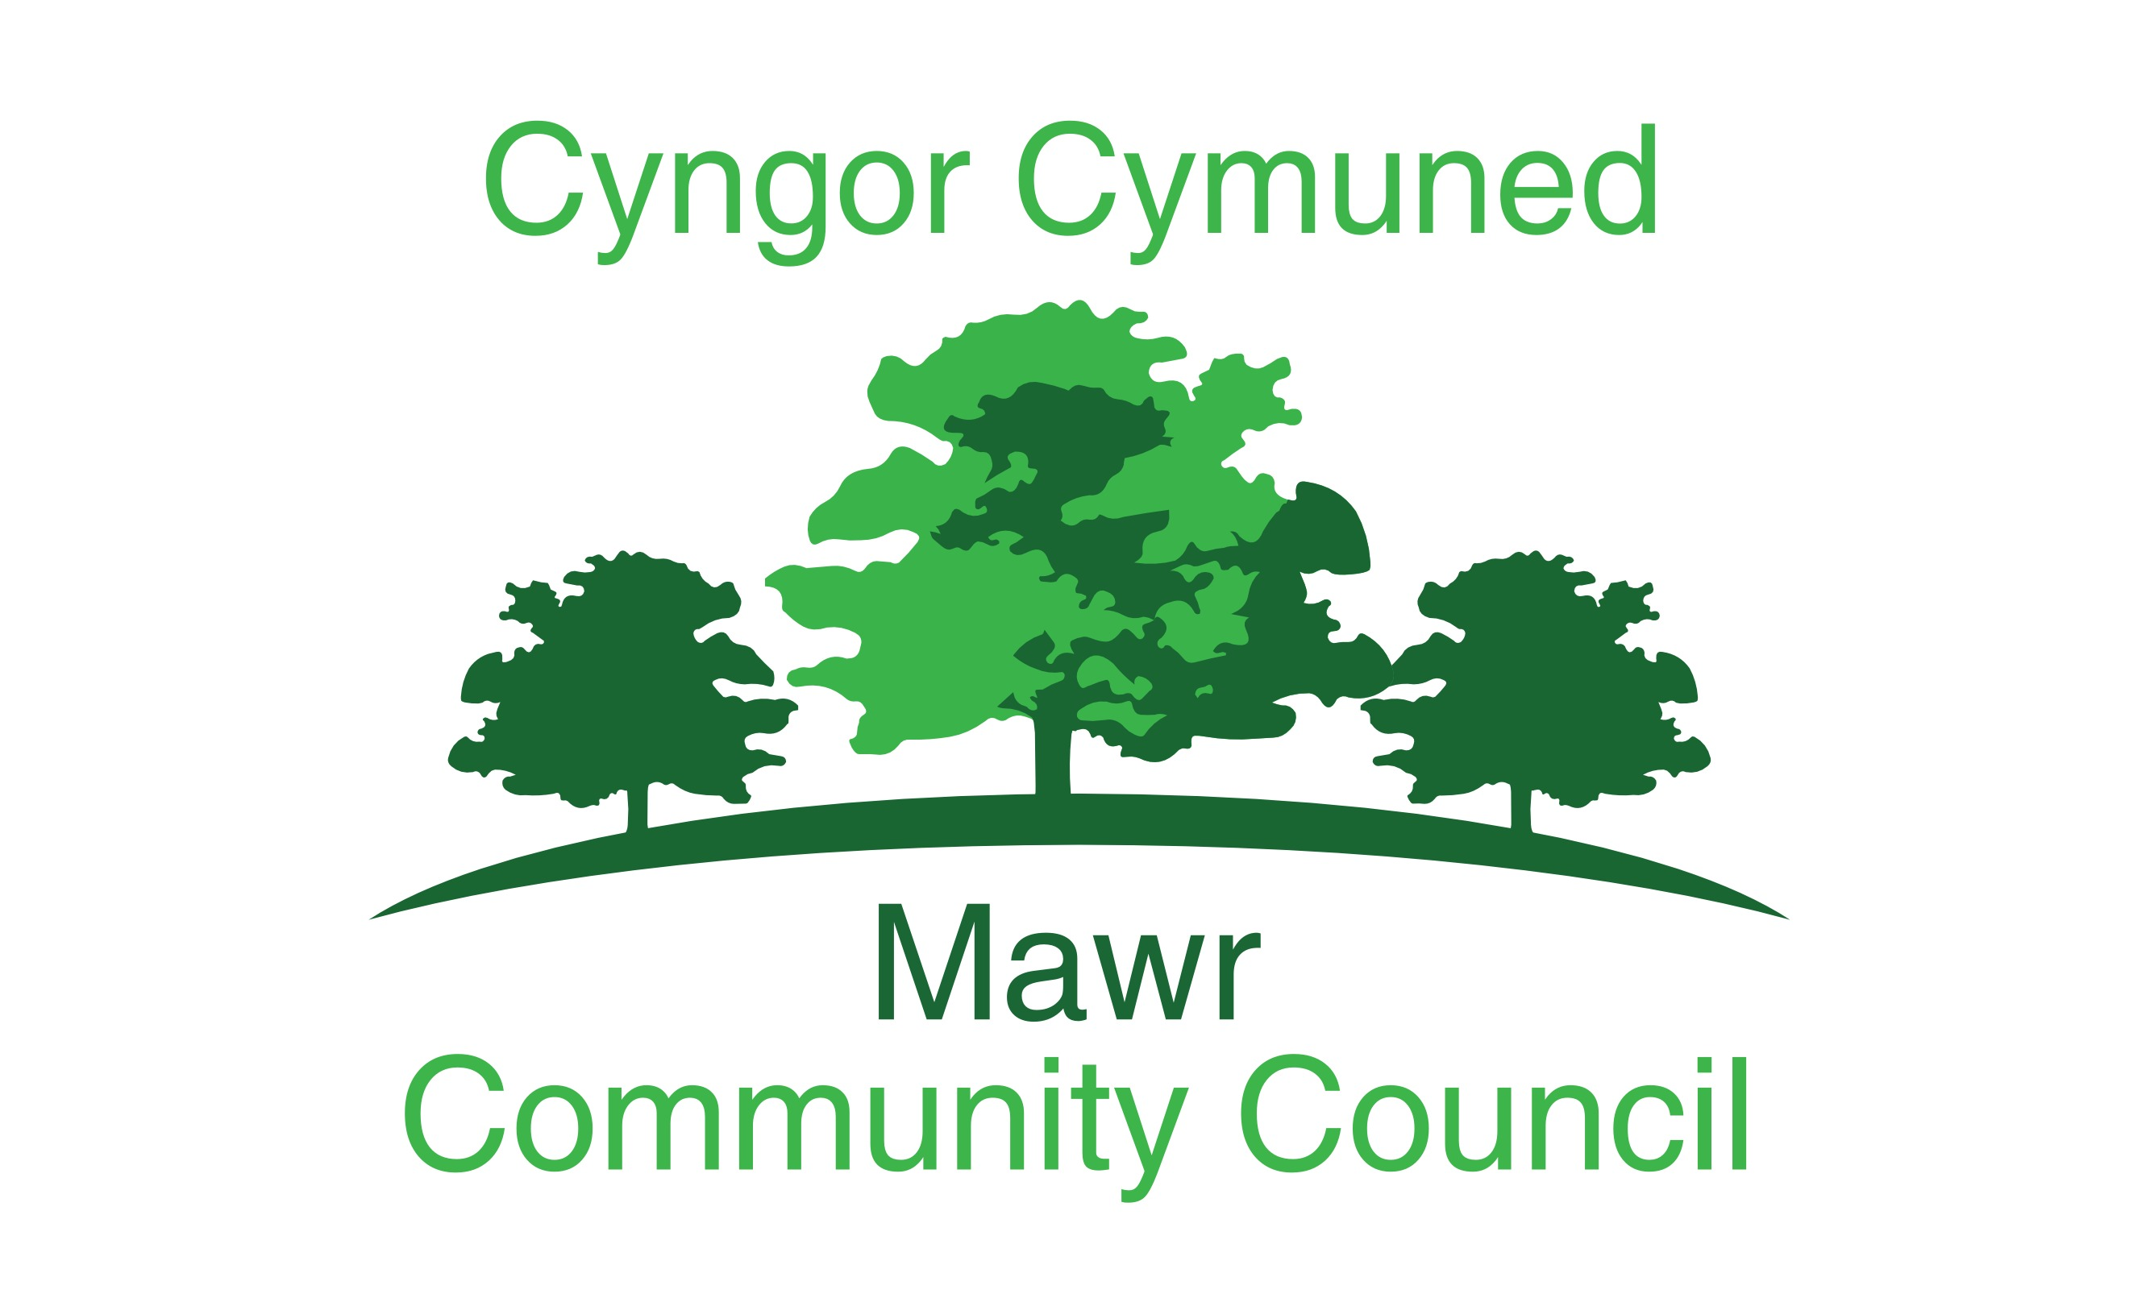

49 Awel Y Mor

Sketty, Swansea, SA2 9FL

[clerk@mawrcommunitycouncil.cymru](mailto:clerk@mawrcommunitycouncil.cymru) 07730 527745

**Councillors are summoned to attend the AGM of the Mawr Community Council at 7:00pm on the 22nd June 2020 via Go To**

**The order of business shall be as follows;**

1. **The election of the Chairperson of the Council for 2020/21**
2. **The election of the Vice-Chairperson of the Council for 2020/21**
3. **Apologies for absence.**
4. **Declarations of Interest**
5. **The business of the annual meeting shall include:**
   * 1. **Signing by the Chairperson, Vice Chairperson and Councillors of their acceptance of office forms**
     2. **Confirmation of the accuracy of the minutes of the last AGM of the council;**
     3. **Receipt of the minutes of the last meeting of a committee;**

**None**

* + 1. **Consideration of the recommendations made by a committee;**

**None**

* + 1. **Review of delegation arrangements to committees, sub-committees, staff and other local authorities;**
    2. **Review of the terms of reference for committees;**
    3. **Appointment of members to existing committees;**
    4. **Appointment of any new committees in accordance with standing order 4 above;**
    5. **Review and adoption of appropriate standing orders and financial regulations;**
    6. **Review of arrangements, including any charters and agency agreements, with other local authorities and review of contributions made to expenditure incurred by other local authorities;**
    7. **Review of representation on or work with external bodies and arrangements for reporting back;**
    8. **Review of inventory of land and assets including buildings and office equipment;**
    9. **Confirmation of arrangements for insurance cover in respect of all insured risks;**
    10. **Review of the council’s and/or staff subscriptions to other bodies;**

**That this Council subscribe to the SLCC and One Voice Wales for the Clerks assistance and information in running this council.**

* + 1. **Review of the council’s complaints procedure;**
    2. **Review of the council’s procedures for handling requests made under the Freedom of Information Act 2000 and GDPR;**
    3. **Review of the council’s policy for dealing with the press/media; and**
    4. **Determining the time and place of ordinary meetings of the full council up to and including the next annual meeting of full council.**

**27th July**

**24th August**

**21st Sept**

**26th Oct**

**16th Nov**

**7th Dec**

**18th Jan**

**15th Feb**

**22nd March**

**19th April**

**17th May - AGM**

* + 1. **To discuss Charitable Donations.**
    2. **To appoint a representative for One Voice Wales**
    3. **To re-appoint the Internal Auditor.**



**Rachel Bull; Clerk to the Council**