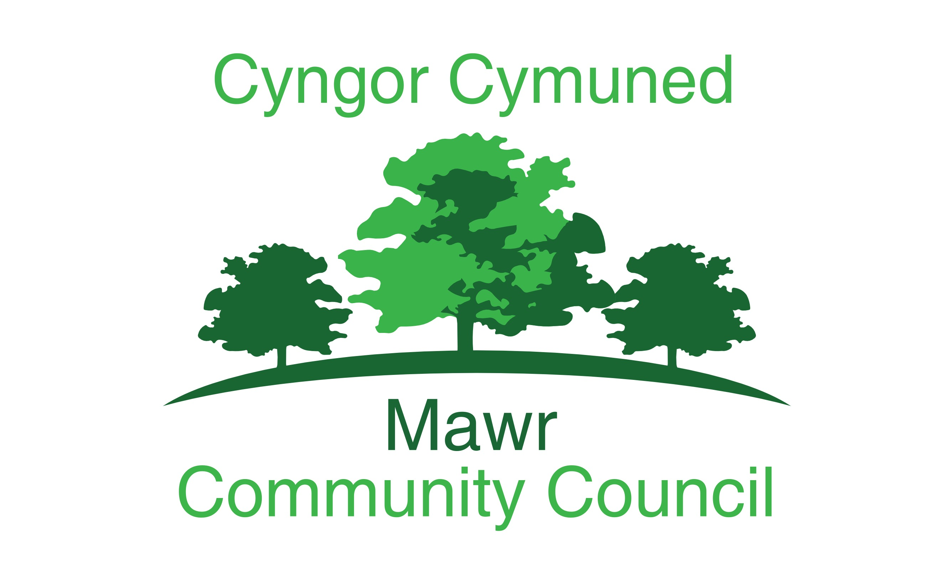

Clerk: Rachel Bull

49 Awel Y Mor

Sketty, Swansea, SA2 9fl

[clerk@mawrcommunitycouncil.cymru](mailto:clerk@mawrcommunitycouncil.cymru) 07730 527745

www.mawrcommunitycouncil.org.uk

**Councillors are summoned to attend an additional meeting of the Mawr Community Council held via Go To on 22nd June 2020 at 7.30pm.**

**The order of business shall be as follows:**

1. Apologies for absence
2. Declarations of Interest
3. To Approve the Audited Accounts, Figures and supporting documentation for the period ending 31st March 2020
4. To Review the Internal Auditors Report
5. To Review and Sign the Completed Annual Return for the period ending 31st March 2020



**Rachel Bull**

**Clerk to the Council**