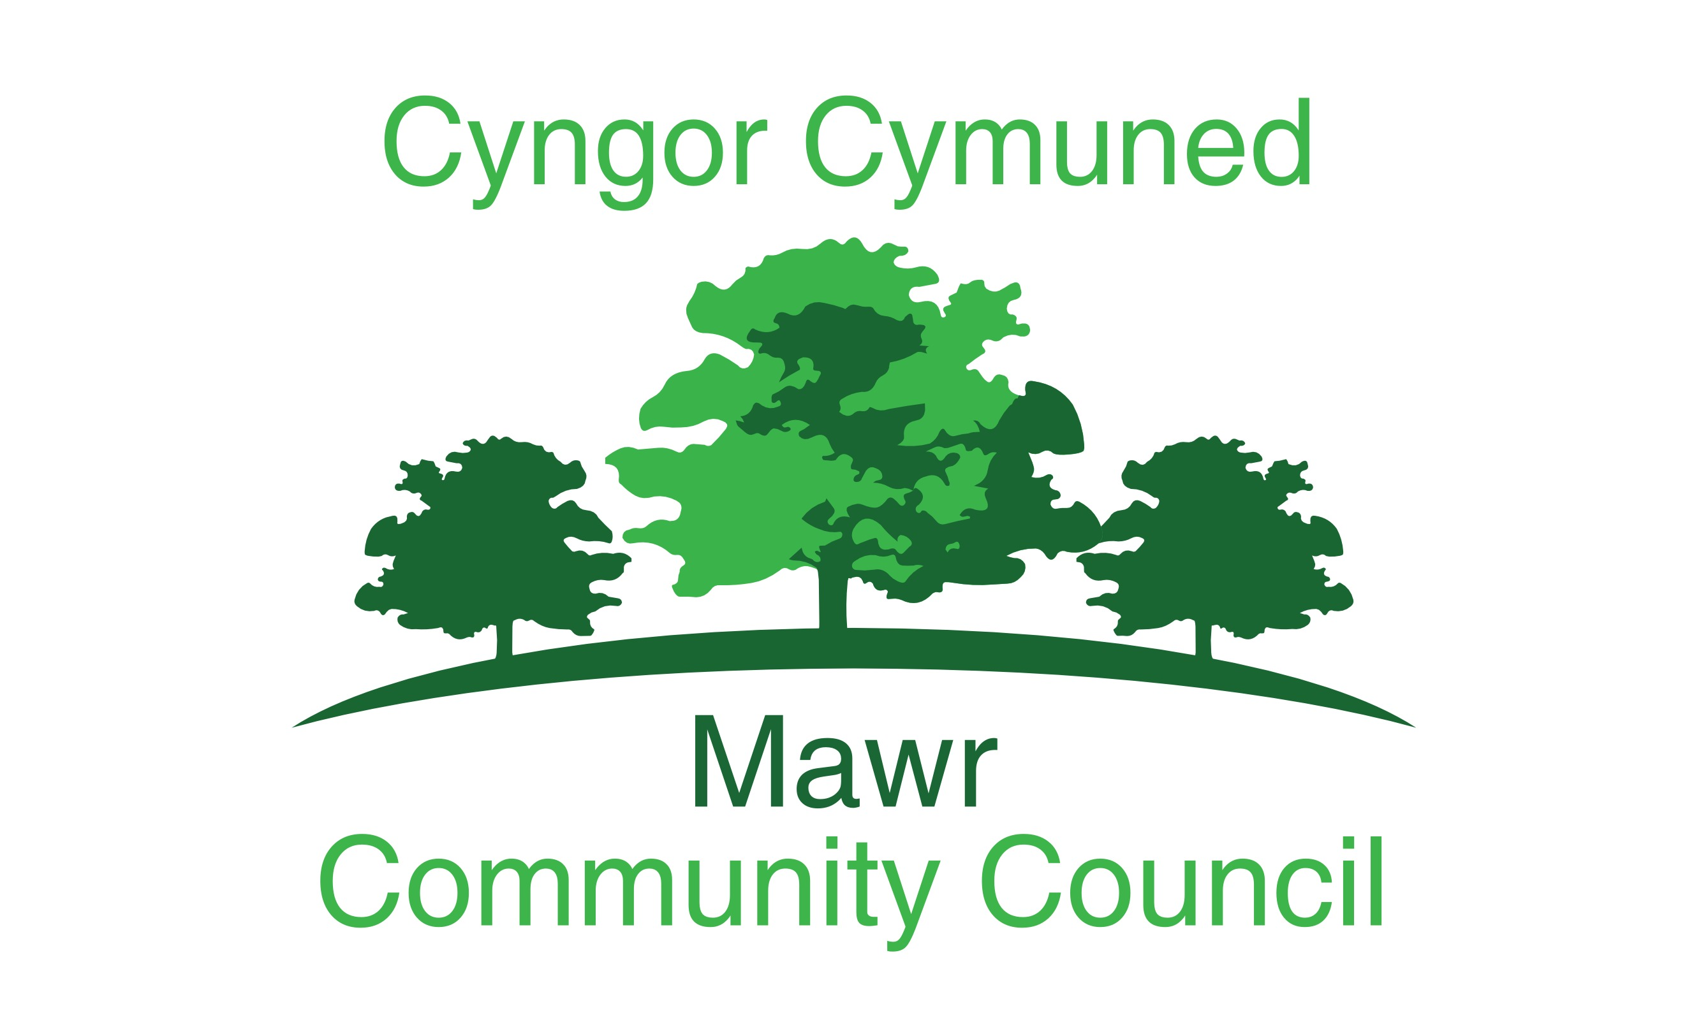

Clerk: Rachel Bull

49 Awel Y Mor, Swansea, SA2 9FL

[clerk@mawrcommunitycouncil.cymru](mailto:clerk@mawrcommunitycouncil.cymru)

www.mawrcommunitycouncil.org.uk

07730 527745

**Minutes of the meeting of the Mawr Community Council held at via Microsoft Teams on 18th January 2021at 7pm. For the transaction of the following business:**

**Present:** Chair L Frame, I Price, T Roberts, J Hallett, Glyn Morgan

# APOLOGIES FOR ABSENCE

**None**

1. **TO RECEIVE DECLARATIONS OF INTEREST**

**None**

1. **Reports from the County Councillor**

**1/2021**

The road in Rhydypandy will now be closed for the next 6 weeks. There is a diversion through llangyfelach road and highways will also be doing repair work to potholes and the road edges.

Cllr Morgan advised that there was a large pothole hole going into the Gas station, Cllr Rowlands will advise highways.

Corona virus vaccines are being rolled out across Mawr, could residents please wait to be called rather than ask their GP.

Cllr Morgan Advised that the pavement on Bwlchgwyn if still full of leaves and has not yet been cleaned by CCS, it is very slippery and dangerous.

Cllr Rowlands advised that the team from CCS were awaiting a change in the weather and then they will be able to clean the pavements,

Cllr Morgan has also reported overflowing drains by the Shephard’s Pub to CCS.

1. **Report on Grant Applications**

**2/2021**

Report from the Grant officer as follows:

* Since November 8 Funding applications have been submitted
* Food Poverty Grant submitted end of November was successful - £2466 to purchase 2 metal sheds
* ICF Funding application submitted before Christmas was successful - IT equipment for Hall in Craig Cefn Parc 4 laptops, Smart Board & web camera- £8642
* On advice from Alyx Baharie from SCVS two further applications have been submitted for IT equipment for Felindre and Garnswllt Halls – awaiting outcome. Garnswllt installation costs for the Smart board have been added to the Mynydd y Gwair internal work application on advice from Director from SCVS. This was due to the timescales for the money to be spent.
* Three applications have been submitted to Mynydd Y Gwair grant – two applications for Garnswllt Hall £28472 for the external and £8418 for the internal work + installation of smart screen and application for a Multi -Use Games Area (MUGA) in Craig Cefn Parc £30,000 . Awaiting outcomes of those applications
* RDP application has been submitted for the creation of a Community Supported Agriculture (CSA scheme) £49,119

The Council thanked the Grant officer for all her hard work.

1. **Public Forum**

None

1. **Confirmation of the accuracy of the minutes**

**3/2021**

**Resolved: The minutes for the December meeting 2020 were reviewed and approved – All in Favour**

**4/2021**

**Resolved: The minutes for the Budget Meeting in November 2020 were reviewed and approved with one addition – the further funding will be made through grant application – All in Favour**

1. **Matters rising from the minutes**

**5/2021**

***Clerk to buy Grant Book - Completed***

***Speak to welsh ambulance re defibrillators – ongoing put an item on next agenda re possible adoption of defibrillators/ information on how we service them as a council***

***Obtain 3 builder quotes for Garnswllt Hall – Completed***

***Clerk to Liaise with Cllr Morgan re letter – to do***

***Can the Garnswllt Hall keep the existing stage – to do***

***Send £200 to friends of CCP - Completed***

1. **Participatory Budget**

**6/2021**

The clerk had received an email from the Children’s welsh ambulance asking for donations.

**Resolved: That £500 be sent to the Children’s Welsh Ambulance service and another £500 if money was left in the budget at the end of the year – All in Favour**

***Action: Send £500 to Children’s Welsh Ambulance***

1. **Discuss broadband provider**

**7/2021**

The Clerk gave quotations to the council all were in the form of 24-month contracts. Due to the current speed of the WIFI in Garnswllt hall and the works being undertaken it was discussed agreed that the clerk should look into the pricing of 12-month options and report back at the next meeting.

***Action: Look into 12-month contracts and report back at next meeting.***

1. **Discuss and approve Tender process for Grounds Maintenance Companies**

**8/2021**

The Grounds maintenance contract is due for renewal in April 2021.

The chair advised the Clerk to look in the standing orders for the tendering process.

The clerk needs full details of the areas maintained so that she can get further quotes as she has a list of the areas but is not sure on all of their whereabouts

*Action: Chair to send clerk list of areas that come under the contract*

1. **Discuss and approve the plan to run Community Supported Agriculture venture in CCP**

**9/2021**

An application has been made for grant funding for a community supported agriculture site in CCP.

The site in CCP would consist of 7 raised beds and 2 sheds. Seasonal vegetables would be grown in the site and sold in veg boxes to local residents who sign up for 12 months at a time and pay a set monthly fee. Volunteers would help run the site and there would be 3 people employed for the project.

Tom O’Kane had been working with Cllr Frame on the site plan. The raised beds would be roughly 10 x 2 metres and there would be a need for 2 poly tunnels in the future. It is possible that a pre-application for planning would not be needed and that a full application could be made by the council which would cost around £400. The site would be managed by Friends of Craig Cefn Parc, but the 3 staff would be staff of Mawr Community Council, the grant application has gone in in the name of Mawr Community Council as Friends of CCP do not own the land. All the accounts from the sale of vegetables and the buying of seeds etc. would be managed by the project manager.

If successful, the grant will cover the cost of the CSA for 18 months after that the CSA should be self-sufficient and if for some reason it is not sustainable the council can shut it down.

The other 2 staff would be a co-oridinator for the volunteers and a cookery teacher who would teach cookery lessons from CCP welfare hall and use the produce from the CSA. Lesson will be available remotely through the new digital screen in the hall which can be broadcast live and then put on u tube,

Going forward the subscriptions to the veg boxes should cover the cost of the employees.

Clerk asked if a separate bank account would be need?

Action: Clerk to check with Auditors re separate bank account for CSA

The CSA would increase bio-diversity in the area, there are no bats in the area but checks still need to be made to see if there are any great crested newts.

The area would be fenced to stop dogs fowling on the raised beds but access next to the area would still allow dog walkers past the garden.

The Clerk would line manage the staff and her time would be the only increased cost to the council.

**Resolved: That the Council give permission for the use of land at CCP off of Ffordd Ellen to be used for a community supported agriculture project if grant funding is successful – All in Favour**

1. **Discuss and Approve submission and meeting the cost of a planning application for the CSA in CCP**

**10/2021**

**Resolved: The Council agrees to submit and pay for the planning application needed for the CSA in CCP which would be between £400 - £750 – All in Favour.**

1. **Grant Application Quotations**

**11/2021**

Due to the natural of grant applications and the tight deadlines surrounding them it is not always possible or practical to submit all the quotations that are being submitted with the application to the full council.

The council agreed to the following process:

**Resolved: That for Grants being applied for in the name of the council the Grant Co-ordinator works with the councillors of the ward area that the grant falls under and present them with the quotations before submission if it is not practical to include them at the next full council meeting.**

**If the Grant Co-ordinator is working for a community group or one of the hall committees the quotes do not need to be seen by the council/councilors – All in Favour**

1. **Garnswllt Hall Builder Quotations**

**12/2021**

The grant for the under pining works had been applied for and all quotations had been submitted as follows:

Under Pinning:

Roger Bullivant – £24,981 plus VAT

BLP Groundworks – £17,500

2 other no quotes

Preparation and re-instatement works – All plus VAT:

Rowan Evans – £6,500

M Tench – £19,500

C Pugh – 17,250

Due to the nature of the under pining the kitchen would need to be removed from the hall at a price of £2,500 plus VAT or the underpinning could be done from the outside costing £3,491 plus VAT

However members of the Garnswllt Hall committee had agreed to take out the kitchen themselves and some of the stage as needed which would save some money from the £2,500 quotation.

**Resolved: That Roger Builivant be hired to do the under pinning and rowan evans be hired to do the underpinning prep and re-instatement subject to the Grant funding being successful – All in favour**

1. **Reports from Committees, Sub Committees and Working Parties**

**13/2021**

The F & E committee had met with regards to Youth Staff Furlough and this will be discussed under staff matters

1. **Report from the Chairperson**

**14/2021**

Work in CCP hall is progressing however they have had problems with rising damp in the new kitchen area and had to have the flooring re done and the wall plastered, and the issue was now sorted. They are now just waiting to paint the walls.

1. **Report from the Clerk**

**15/2021**

Clerk had been approached by the census department about getting the council involved in spreading the word to the local community about doing the census.

The clerk had forwarded the precept form to CCS

***Action: Clerk to approach CCP Hall Committee to see when they could attend a trustees meeting***

1. **Report from the Community Councillors**

**16/2021**

**Cllr Morgan:**

There have been some issues in Felindre with regards to anti-social behavior in the car park, car have driven over the football field and cars had been parking in the car park at night.

New gates had just been installed after the last gates were stolen and this will restrict the vehicle entry.

A suspect substance was found in the car park and police have asked the Hall committee to look through their CCTV to see if they could get the cars number plate.

*Clerk to liaise with Cllr Morgan to out together a letter from MCC about these issues and ask them to a meeting on what they will be spending the funding on.*

**Cllr Roberts:**

The lock on the defibrillator is now working

**Cllr Sterio:**

Fagwr lane is overgrown, as it is a public footpath Cllr Rowlands will look into it.

**Cllr Northcote**

People are still driving to get to the Lliw Valley reservoir, recently there were 16 cars parked outside which is against current covid legislation.

1. **To Consider Planning Applications**

**17/2021**

The Rock and Fountain pub in Craig Cefn Parc has applied for change of use as its current owners wish to close the pub, it has been up for sale for some time, they now wish to turn it into a house and sell it.

Cllr Rowlands had been approached by about 40 villagers were against the change of use and Cllr Sterio also was against the change of use due to it being the only thing left in the village after the school and post office had closed down. There are no other pubs within a safe walking distance.

**Resolved: Clerk to lodge an objection to City and County of Swansea. All in Favour**

1. **Correspondence**

**18/2021**

The clerk had received an email from Garnswllt Hall Committee. It complained that Cllr Roberts had a key to the door and also said that when he had been meeting contractors he had not been socially distancing or wearing a mask or signing the visitor book.

Cllr Roberts advised that having a key was necessary to enable all the quotes to be obtained for the roof work and had consulted the clerk before getting the key.

He denied that he had not been wearing a mask etc. and provided pictures of where he had been signing in from the visitor’s book.

With regards to the Co-op funding the clerk is to look into if the hall committee can keep it in the hall bank account, it is noted that their constitution allows them to work on projects for the community, but it was noted that this was raising funds for a playground which was already owned by city and county of Swansea.

Action: Clerk to contact auditors and look at terms of the fund and to respond to the hall committee email.

Sadly Mr. Edwards, who has helped the council out so much with health and safety matters, gave the sad new that his wife has passed away – the clerk had sent a condolence card on behalf of the council.

Action: To establish if the Edwards family would like flowers for the funeral or donations to be made.

1. **Financial Report and Presentation of Payments to be Made**

**19/2021**

Financial Reports for January 2021 were reviewed and approved

**Resolved: That the accounts, reconciliation, and payments for January 2021 have been reviewed and approved.**

**Motion carried - All in favour**

**20/2021** – Standing orders suspended

1. **Staff Matters**

**21/2021**

The future of the Youth clubs in Felindre and Garnswllt were discussed.

The council had been paying staff on full pay throughout the lockdown since March 2020.

It did not look like the Youth Clubs would be able to open any time soon due to the covid restrictions.

The Council cannot apply for furlough as they receive their precept from the local authority and are therefore not eligible.

**Resolved: That as the Youth clubs had been closed since March 2020 the 3 staff are to be made redundant from 31 Jan 2021. The staff are to be offered their job back as soon as the clubs are able to re-open – All in Favour**

*Action: Clerk to consult with staff and work out necessary redundancy pay.*

The clerk is also due her appraisal and the meeting will be set for a date in February.

1. **Date and Time of Next Meetings via Microsoft Teams**

**22/2021**

**F&E Committee Meeting – Clerks Appraisal – 8th February -7pm**

**Full Council Meeting – 15th February 2021 – 7pm**

**Full Council Meeting - 16th March 2021 – 7pm**

**Meeting Closed at 9.40pm**



**Rachel Bull - Clerk**