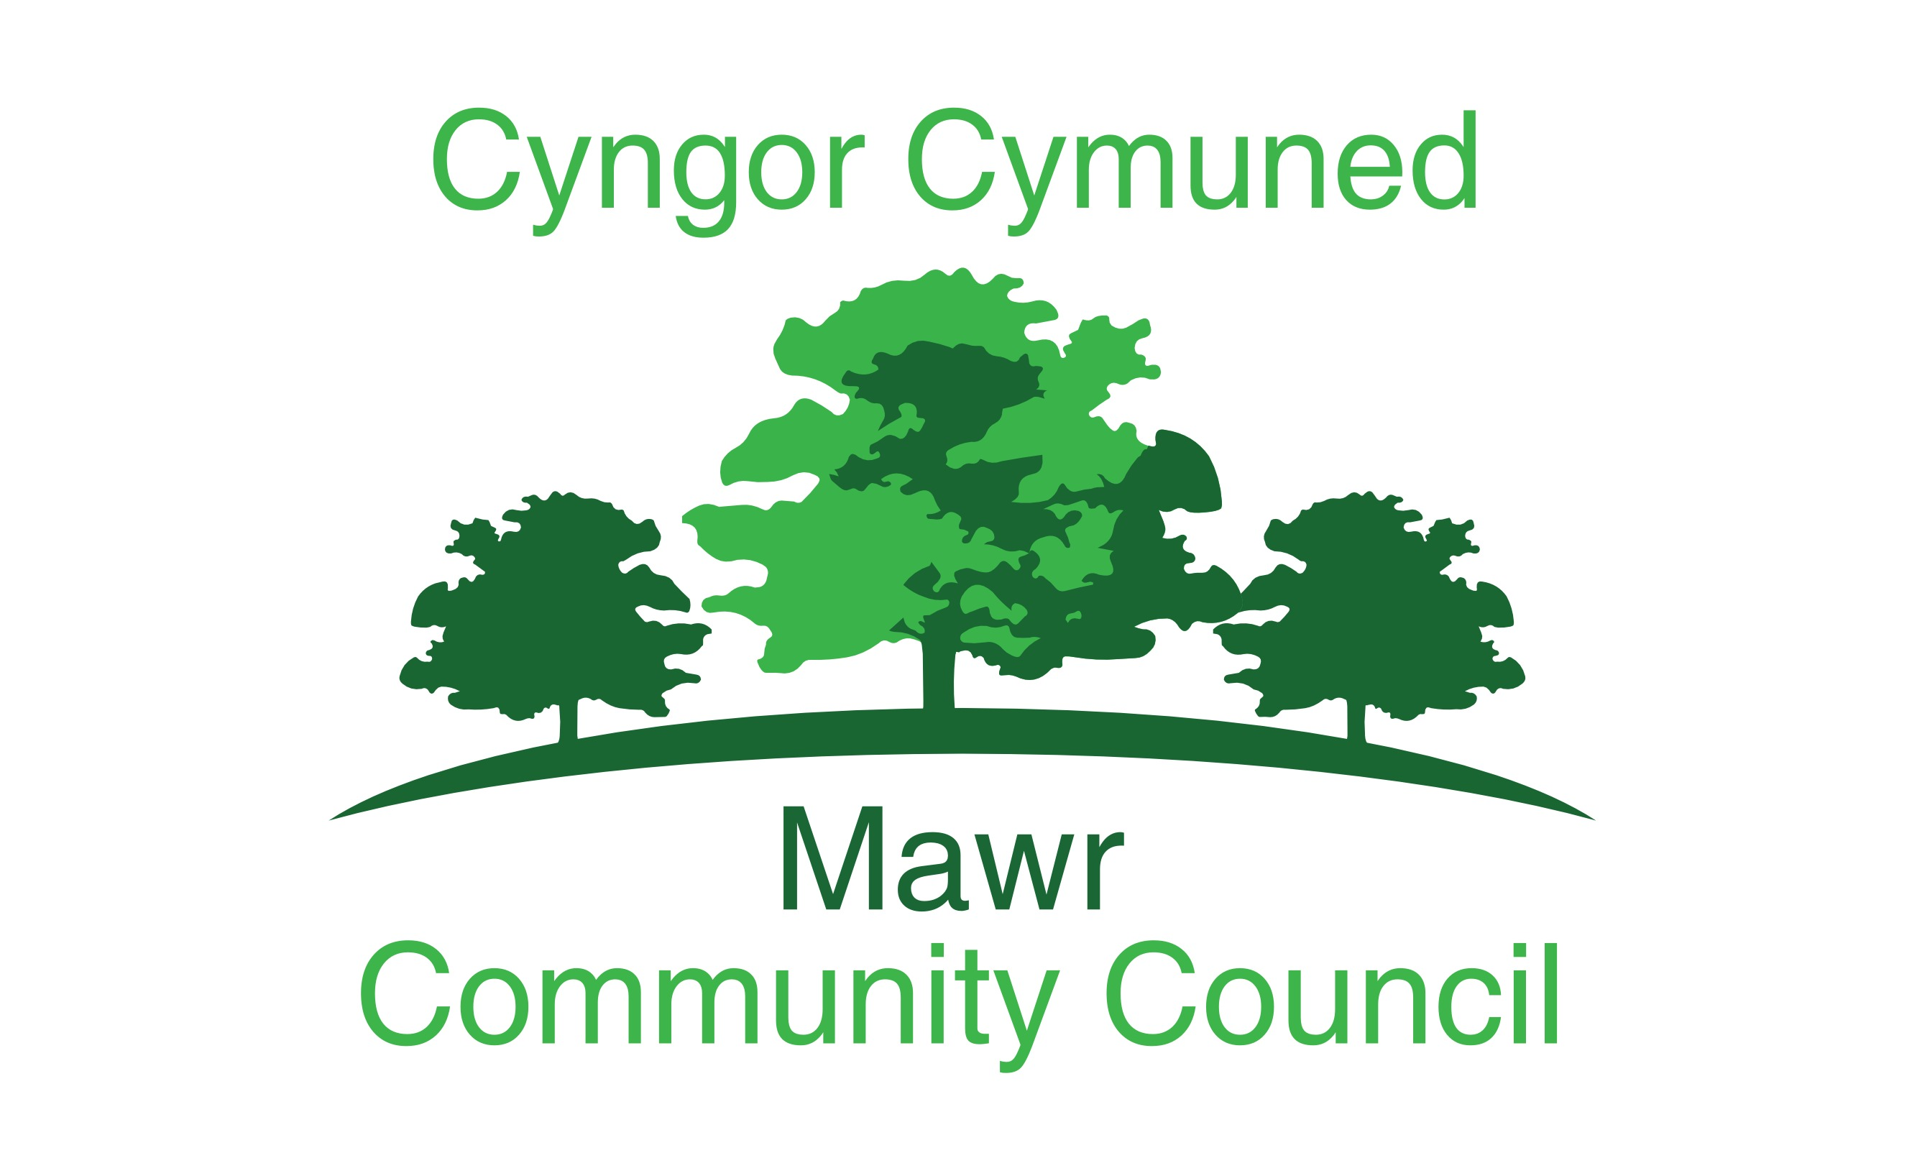
Clerk: Rachel Bull
49 Awel Y Mor, Swansea, SA2 9FL
clerk@mawrcommunitycouncil.cymru
www.mawrcommunitycouncil.org.uk
07730 527745

Minutes of the meeting of the Mawr Community Council held at via Microsoft Teams on 16th March 2021 at 7pm. For the transaction of the following business:

Present: Chair L Frame, I Price, T Roberts, J Hallett, G Morgan, J Stereo and
P Northcote

APOLOGIES FOR ABSENCE
None

- TO RECEIVE DECLARATIONS OF INTEREST
None

- Reports from the County Councilor
42/2021
County Councilor not in attendance

- Report on Grant Applications
43/2021

Report from the grants officer as follows:

- Submitted application to VSEF fund for £833.40p for electric height adjustable stand for the interactive screen for Craig Cefn Parc Welfare Hall. The idea for the stand to make the use of the screen accessible for all came after CCP ICF application had been submitted and approved so couldn’t reapply to the same fund. Felindre & Garnswllt had it included in their applications. The funding has been successful so all three halls will have the same equipment.
- Working with Social Farms and Gardens to achieve CLAS Award for Friends of Craig Cefn Parc. CLAS is Community Land Advisory Service. This is not a monetary award but can be used to attract further funding– FoCCP have received £5000 from social farms and gardens for raised beds for community growing area which will include the funding successfully applied for from Food Poverty Grant for the shed, greenhouse and tools.
- In the process of writing three applications for Community Change Makers Fund for Felindre, Craig Cefn Parc and Garnswllt. Funding is for up to £1000. Felindre for new picnic benches outside the hall, Craig Cefn Parc for fencing and a gate to go around the pond/bog area to make it safe for children. Garnswllt for new football posts
- Researching the appropriate funding sources for the list of items for hall in Felindre. Awards for All and Coalfields Regeneration Funds are the main two that will be looked at for applying. If successful Bernard Sunley and Communities facilities programme can be applied to as match funding is required for those.
- Letters have been sent off to a few charitable trusts that had been identified through the grant/trust book for funding for Felindre
- Awards for All has been identified as best option for work required on Craig Cefn Parc Welfare Hall – This is to make it more accessible with outside ramp and other items. Waiting on quotes which are being sought at the moment.
- Had the opportunity to meet Linda at Craig Cefn Parc a few weeks ago to get a better understanding of the area to be developed at Ffordd Ellen
- Zoom meeting arranged with Holli Yeoman regarding funding requirements for Forest School area off Ffordd Elllen in CCP.

The Council thanked the grants officer for all her hard work.

- Public Forum
None

- Confirmation of the accuracy of the minutes
44/2021
Resolved: The minutes for the February meeting 2021 were reviewed and approved – All in favour
Proposed by Cllr Roberts Seconded by Cllr Price

- Matters rising from the minutes
45/2021
Councilor Price – 17- 36/2021 Reiterated his concerns over the variation of interpretation of the current use of council land by dog walkers
Action – this to be included as an Agenda item for the next meeting

- Participatory Budget
None

- Contract with Servicemaster
46/2021
Servicemaster had advised the council that the National Living Wage is to increase by 2.2% in April 2021, therefore their charges would increase proportionally for each hall clean.
Matter was discussed by the council.

Resolved: Motion proposed to accept the increase by Cllr Morgan and seconded by Cllr Hallett – All in favor

- Deep cleaning of Welfare Halls - Discuss and approve Servicemaster to view the Halls and quote for the deep cleaning
47/2021
It was agreed that the Chair would liaise with Servicemaster and the Hall Keyholders, to arrange visits and agree dates when the work will take place.

Action: It was agreed that the Chair would liaise with Servicemaster and the Hall Keyholders, to arrange visits and dates when the work will take place

- Discuss and approve the plan to run Community Supported Agriculture venture in CCP
48/2021
The Chair reported that due to the fact the Council is unable to legally accept grant funding for the CSA and her extensive efforts to establish a person or group to take on the project have not been successful, the project cannot proceed.

Action: No Action

- Discuss and approve planning application for poly-tunnel
49/2021
It was discussed, the council will put in a planning application for the polytunnel, this will be completed by the Chair.

Resolved: The motion was proposed by Cllr Morgan and seconded by Cllr Hallett

- Garnswllt Hall builder quotation and underpinning works
50/2021
During the course of the works being completed, Asbestos was found within the area of the pathway which had to be removed and tested. A local company, Anchem, carried out the test and advised on safe removal from the site when the roof work is completed. The work is progressing well and is expected to be completed by the 26th of March.
An issue has arisen concerning the brick structure that supports the floor in the “back room”, this has had to be demolished by the contractors in the course of their work, also rainwater drainage pipes need to be replaced, Cllr Roberts to liaise with the Builder to reconstruct the wall, install new pipes and agree skips that may be required for disposal of waste. These costs and the wall and drainage costs should be covered by the reduction of work created by the kitchen not being removed. Cllr Roberts to report back.

Resolved: Cllr Roberts to discuss the wall and additional costs with the Builder to confirm that this is covered within the original quoted amount and to report back to the council

Action: The next stages of the project are the renewal of the roof and electrics, Cllr Northcote to speak to the Clerk for information of quotes and details for both items

- Defibrillators
51/2021

The subject of defibrillators was discussed and it could be a good idea to have one at Felindre Welfare Hall. However, this would have to be passed by the Felindre Hall Management Committee.
General discussion on the potential for additional defibrillators across
Mawr.

Action: it was agreed that Cllr Morgan would take the proposal to install a defibrillator at Felindre Hall to the Hall Committee. Also, all councilors would look at their local area to see if there are additional defibrillators required and report back at the next meeting

- Reports from Committees, Sub Committees and Working Parties
None

- Report from the Chairperson
52/2021
- Chair attended training course entitled “How to respond to planning applications” felt the course was beneficial and would like to attend the follow up course
- Applied to the Charity Commission for an extension for the submission of the accounts for CCP Hall. This was due to the fact that an external audit was required. Extension was agreed.
- Completed report concerning the 2019 summer Play Schemes
- Reported that in absence of the clerk, the services of Dragon accounting have been enlisted for the payments of salaries and invoices,
- Query concerning the key to the padlock for the gate entrance to the field in CCP.

- Action: Cllr Northcote to ask Clerk if she has record of who holds the keys

- Spoke to Bobbie-Jayne (Youth Leader, Garnswllt) regarding taking the funds from the youth club to Cllr Roberts
- Chair has explained she is unable to continue completing the Clerk’s duties while she is on sick leave

- Report from the Clerk
No report from the Clerk

- Report from the Community Councilors
53/2021
Cllr Stereo
Concerns over the potholes along Lon Heddwch in CCP

Action: Chair to email Cllr Rowlands

Enquiry to what is happening with the school building in CCP

Action: Chair to email Cllr Rowlands

Cllr Price
The movement of tractors and trailers transporting spoil and earth to a
farm along Heol y Mynydd, leaving the road extremely “messy” on the
return trip. Cllr Price had contacted Cllr Rowlands who seemed
unable to assist. Cllr Roberts gave the contact details of a
person who may be able to assist to Cllr Price.

Cllr Roberts
A problem arose during the underpinning of Garnswllt Hall. Building
materials were blocking access to the defibrillator on the wall. Access
regained after speaking to builders.

Cllr Morgan
Reported that Swansea Council had been busy in various parts of
Felindre, tidying verges and erecting warning posts. However, have not
cleared the debris adjacent to the Shepherd’s Inn as a result of the
heavy rains. Several phone calls made to Swansea Council regarding
this matter.

- To Consider Planning Applications
None

- Correspondence
54/2021
Servicemaster – this was dealt with under Item 9

- Financial Report and Presentation of Payments to be Made
55/2021

Financial Reports for March 2021 were reviewed and approved
Resolved: That the accounts, reconciliation, and payments for March 2021 have been reviewed and approved.
Proposed Cllr Morgan
Seconded Cllr Price
Motion carried - All in favor

56/2021 – Standing orders suspended 9.15pm

- Staff Matters
57/2021
The Clerk is currently on sick leave. Cllr Northcote is
keeping in contact and checking on the Clerk’s wellbeing. It was agreed
that the council would like to alleviate any concerns the Clerk may have about a backlog of work so that she can focus on making a full recovery.

- Date and Time of Next Meetings via Microsoft Teams
58/2021
Full Council Meeting –12th April 2021 – 7.00pm
AGM - 10th May 2021 – 6.30pm
Full Council Meeting – 10th May 2021 – 7.00pm

Meeting Closed at 9.40pm

Minutes Recorded by Cllr Northcote

