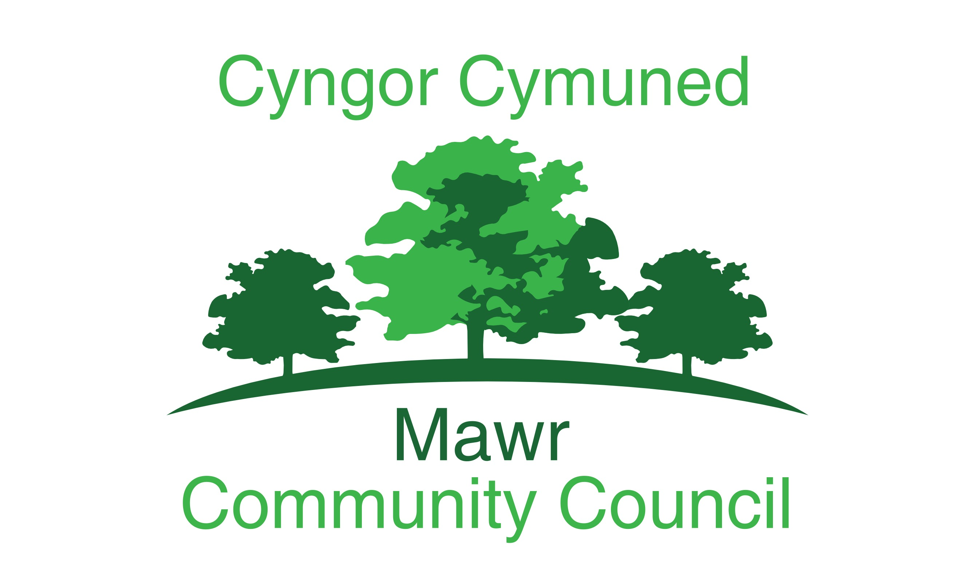
Clerk: Rachel Bull
49 Awel Y Mor, Swansea, SA2 9FL
clerk@mawrcommunitycouncil.cymru
www.mawrcommunitycouncil.org.uk
07730 527745

Minutes of the meeting of the Mawr Community Council held via Microsoft Teams on 15th February 2021 at 7pm. For the transaction of the following business:

Present: Chair Cllr L Frame, Vice Chair Cllr P Northcote, Cllr I Price, Cllr T Roberts, Cllr G Morgan

APOLOGIES FOR ABSENCE
Cllr J Hallett due to difficulties joining the meeting
Cllr J Sterio, Cllr B Rowlands

- TO RECEIVE DECLARATIONS OF INTEREST
Cllr G Morgan Staff Matters Item 1

- Reports from the County Councillor
23/2021

information distributed in emails.

- Report on Grant Applications
24/2021

Report from the grants officer as follows:

- Felindre Welfare Hall Committee successful application for ICF funding for Smart board, lap tops and web camera
Garnswllt Welfare Hall Association successful application for ICF funding for Smart board, laptops and web camera
- MCC successful application for funding from Mynydd y Gwair Community Fund to underpin Garnswllt Welfare Hall
- Garnswllt Welfare Hall Association successful application for funding from Mynydd y Gwair Community Fund to undertake internal construction work relating to the underpinning and installing the Smart board
- Friends of Craig Cefn Parc application for funding from Mynydd y Gwair Community Fund towards MUGA in Ffordd Ellen
- Grants Total - £96,341
- Councillors thanked the grants officer for all her hard work

- Public Forum
None

- Confirmation of the accuracy of the minutes
25/2021

Resolved: The minutes for the January 2021 meeting were reviewed and approved – All in favour

- Matters arising from the minutes
26/2021

- Clerk to contact Garnswllt Hall Association and explain that Felindre Hall Committee has not set a precedent as stated in the minutes of the Hall Association meeting held on 14.01.21
- Clerk to contact Wales Audit Office re: Garnswllt Hall Association bank account
- Clerk to contact Garnswllt Hall Committee re: retaining the existing stage
- Clerk to liaise with Cllr Morgan re: writing a letter to Welsh Water

- Participatory Budget
27/2021

The donation of £500 to the Children’s Welsh Ambulance Service was gratefully received.

Resolved: That £100 be donated to Maggie’s Cancer Charity, Swansea in Singleton Hospital in memory of Mrs Mary Edwards of Felindre – All in favour

Action: Send £100 to Maggie’s Cancer Charity, Swansea,

- Review and agree the Audit Report for 2020/2021 and the recommendations from BDO.
28/2021

Resolved: The audit report was agreed and the recommendations from BDO were accepted – All in favour

- Discuss broadband provider renewal
29/2021

Resolved: That the current broadband provider is retained and the broadband speed in the three halls is monitored after the new IT equipment is installed – All in favour

- Discuss and approve the plan for Community Supported Agriculture site on land off Ffordd Ellen CCP
30/2021

MCC is unable to accept a grant from the RDP for the Community Supported Agriculture Project. Cllr Frame will meet with officers from the RDP to discuss the possibility of a third party setting up a community interest company (CIC) to run the project and submit a fresh application for RDP LEADER funding. MCC could lease the land to a CIC. Cllr Frame will also seek expressions of interest from third parties regarding establishing a CIC. If a CIC is not a feasible option the best course of action would be to cancel the CSA project and continue to support the Friends of CCP with their initiative to create a community garden, forest garden and forest school.

Resolved: That Cllr Frame liaises with RDP officers and any third parties who may be interested in setting up a CIC to run the CSA then provide a progress report at the full council meeting in March – All in favour

- Garnswllt Hall Builder Quotations
31/2021

In order to minimise disruption to the interior of the hall, including removing the kitchen units, the best option would be to underpin the foundations from the outside.

Resolved: That Cllr Roberts liaise with the contractors and arrange for the underpinning to be undertaken from the outside –
All in favour

Action - Clerk to email Roger Bullivant with contact details and start date.

- Defibrillators
32/2021

Resolved: The Clerk will oversee the ongoing maintenance of all four defibrillators and provide regular reports to members - All in favour

Standing Orders suspended at 9:00pm

- Reports from committees, sub committees and working parties
33/2021

None

- Report from the Chairperson
34/2021

The Chairperson met with CCP Welfare Hall Committee. The secretary and the treasurer raised concerns about unpaid rental fees that have been outstanding since 2019. After several unsuccessful requests for payment of the outstanding fees, the Hall Committee has written to the party involved and is waiting for a response before deciding on the next course of action.

Refurbishment of the hall is progressing well. The Committee will apply for further grants to cover the cost of the outstanding internal work, the disabled access ramps, repairs to the paths around the building and a patio area outside the new kitchen so that light refreshments can be served outside with socially distanced seating arrangements.

Action – Clerk to complete planning application for the access ramps and, if required, the patio area.

- Clerk’s Report and Action
35/2021

Planning Aid Wales is providing online training for clerks and councillors on how to respond effectively to planning applications. This is an advanced version of the training that was provided in 2019.

Action – Clerk to register attendance for herself and the Chairperson on the Planning Aid Wales training event

Clerk to post information regarding the 2021 Census and the Senedd Elections in May 2021 on the council’s website, Facebook page and in the noticeboards

- Report from the Community Councillors
36/2021

Cllr Northcote:
Felindre Welfare Hall Committee has received a grant to purchase an interactive Smart board, electric adjustable stand, web camera and laptops.
The Hall Committee continues to work with the grants officer towards submitting an application for the next funding round of Mynydd y Gwair Community Fund
There are bollards all along Llangyfelach Road where the edge of the road is collapsing due to increased traffic resulting from the closure of Rhydypandy Road.
The debris deposited on Heol Myddfai during the recent floods has still not been cleaned up.

Cllr Morgan:
The pavement at Bwlch y Gwin has been cleaned.
Queried when the Clerk would pay the Hall Grants.
The fencing at the end of the football field has been completed.
Requested that MCC purchase and place signs near the football pitch asking people not to walk their dogs on the pitch during the football season.

Action - Clerk to liaise with Cllr Morgan regarding purchasing signs

Cllr Roberts:
Recently tractors have made numerous journeys through Garnswllt on a daily basis. They have been transporting soil that has been excavated from a building site in Ammanford to a site off Heol y Mynydd where it is being dumped. One of the tractors has demolished part of the cemetery wall. The mud that is left on the roads should be cleaned up by the contactor but that hasn’t happened despite several complaints to SCCC.

Cllr Price:
Residents in Garnswllt are complaining that they are not allowed to walk their dogs on the field at the bottom of Lon y Felin.
Members expressed concern that dog walkers do not always clean up after their dogs and children regularly play on the field. They noted that the sign prohibiting dogs has been on display for many years and should remain.

- To Consider Planning Applications
37/2021

No observations

- Correspondence
38/2021

None

- Financial Report and Presentation of Payments to be made
39/2021

Financial Reports for February 2021 were reviewed and approved

Resolved: That the accounts, reconciliation, and payments for February 2021 have been reviewed and approved.
Motion carried - All in favour

- Staff Matters
40/2021

The Clerk has contacted the Youth Leaders and Youth Worker.

The Clerk’s annual appraisal will be completed in February.

- Date and Time of Next Meetings via Microsoft Teams
41/2021

Trustees Meeting with CCP Welfare Hall Committee TBC
Full Council Meeting - 16 March 2021 at 7:00pm
Full Council Meeting - 19 April 2021 at 7:00pm

Meeting Closed at 9.50pm

