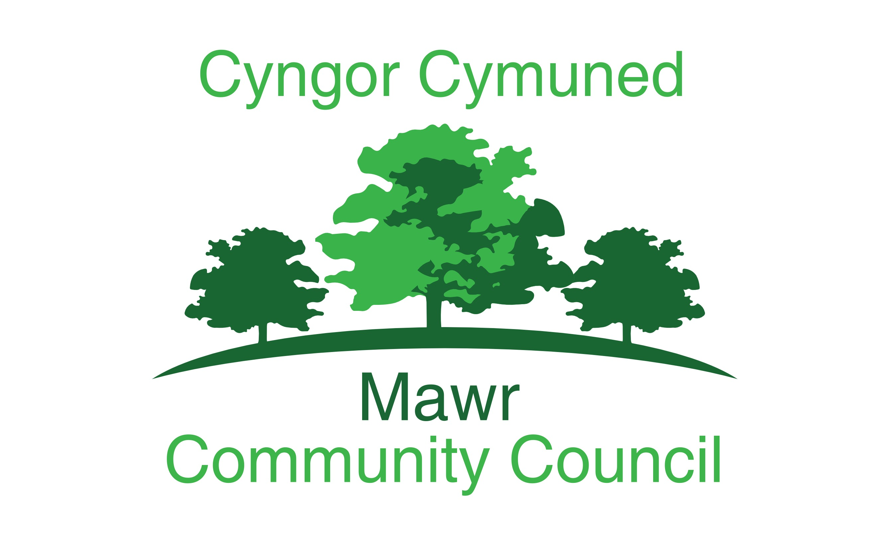
Clerk: Rachel Bull
49 Awel Y Mor, Swansea, SA2 9FL
clerk@mawrcommunitycouncil.cymru
www.mawrcommunitycouncil.org.uk
07730 527745

Minutes of the meeting of the Mawr Community Council held at via Microsoft Teams on 12th April 2021 at 7pm. For the transaction of the following business:

Present: Chair L Frame, T Roberts, J Hallett, G Morgan, J Sterio and
P Northcote
County Cllr B. Rowlands and G. Thomas (prospective temp Clerk)

APOLOGIES FOR ABSENCE
Cllr Price

- TO RECEIVE DECLARATIONS OF INTEREST
None

- Reports from the County Councilor
59/2021
- Lliw Reservior to reopen on the 14th of April, the site will now be subject to car parking charge of £2, Cllr Rowlands had received many objections to this from the Public. Cllr Morgan made the observation that since the footpath thru the woodland adjacent to the Upper Lliw has been opened, road issues along the Golden Mile had occurred, visitors do not have toilet facilities, therefore are “defecating” around the area, people have also been spotted paddle boarding on the Upper reservoir.
Action – Possible agenda items for the next meeting
- Fly tipping – a major problem within the Mawr ward, when asked what the C&C of Swansea are going to do, a potential solution is in process of being approved, no specific details in place. A pilot on enforcement strategies is currently out to tender.
- CCP School build was discussed, as extensive works are being completed, however nothing has gone through Swansea planning department.

- Report on Grant Applications
60/2021

Report from the grants officer as follows:

- Covid sustainability grant for playschemes from Swansea Council has been awarded £400 for the summer schemes in the three halls.
- 2 Applications have been submitted for Change Makers fund Felindre and Craig Cefn Parc – end of April/early May for outcome.
- CLAS award for Friend of Craig Cefn Parc for the community growing project was successful Not a monetary award but can be used to demonstrate good practice and the status of the project to be used for further funding applications.
- Awards for All grant application for Felindre has been written for new flooring and security system final preparations and will be ready to be sent off.
- Looking to work with Forest School on funding application for project in Craig Cefn Parc. Contacted the Postcode Lottery and it meets their eligibility criteria. Will need further discussions with Holli Yeoman and can then start writing application.
- DPD Eco fund has been identified to apply for LED lighting for Felindre Hall. Application has been started and quote is being organised.
Started obtaining quotes for outdoor equipment for an exercise trail in Felindre. Healthy Hearts Grant opens up on 20th April for up to £10,000 to encourage being active
The Council thanked the grants officer for all her hard work.

- Public Forum
None

- Confirmation of the accuracy of the minutes
61/2021
Resolved: The minutes for the March meeting 2021 were reviewed and approved – All in favour
Proposed by Cllr Roberts Seconded by Cllr Hallet

- Matters rising from the minutes
62/2021
Cllr Frame - Item 10- 47/2021- Servicemaster contacted the council,
wishing to withdraw from the current contract with immediate effect, Cllr
Frame contacted them and discussed, the main issue being the travelling
to Garnswllt. Cllr Frame stated it was agreed that the contract to clean …...the halls in CCP and Felindre would continue.
complete the deep cleans for the May elections, however this leaves
a deep clean being required for Garnswllt Hall, after discussion it was
suggested by CC Rowlands that a local company Saphire Cleaning,
maybe a solution
Resolved: Cllr Frame to contact local cleaning companies in the
Garnswllt area – All in favour
Proposed by Cllr Morgan Seconded by Cllr Roberts

Cllr Morgan – Item 14 – 51/2021 Positioning of defibrillator at Felindre
Welfare Hall, it was agreed that the unit would be sited on the end wall of
the hall facing the road.

Cllr Northcote – Item 16 – 52/2021 – Contacted the Clerk concerning key
for the playing fields at CCP, no keys available, however no key required
gate is not currently locked.

Cllr Sterio – Item 18 – 53/2021 – Potholes on Lon Heddwch, these have
these now been filled in by Swansea Council,
Work on the old School building in CCP covered by report from Cllr
Rowlands.

- Participatory Budget
None

- Contract with Servicemaster
62/2021 Covered in Item 7

- Contract for Grounds Maintenance
63/2021
Clerk, had not obtained quotes for the contract renewal process for the
Grounds Maintenance contract which ends in April 2021.
Cllr Frame contacted OVW for advice, the following options were advised
by Paul Egan OVW
- If it is not possible to seek competitive quotations before the commencement of this year’s grounds maintenance contract Council should consider the position, suspend its financial regulations and possibly agree to extend the current contract by one year and go out to quotation next year.
Cllr Morgan’s view to extend the contract for another year.
Cllr Frame had spoken to current contractor to complete the first cuts while Council considers this matter.
Resolved: Council to suspend financial regulations, extend the
current contract by one year and go out to quotation next year
- All in favour
Proposed Cllr Sterio Seconded Cllr Morgan

- Garnswllt Hall renovation works
64/2021

Deferred for consideration under item 22 Financial Report

- Access for dog walkers - Discuss and approve allowing dog walkers to access the Community Council’s playing fields and recreation areas.
65/2021
Item not discussed Cllr Price had sent his apologies, to be deferred to the next meeting

- Youth Club funds – To approve receipt of monies from Garnswllt Youth Club -
66/2021
Monies were handed to Cllr Roberts from one of the Youth workers, Cllr Roberts had passed these onto Cllr Frame.
Resolved: Monies to be paid into the Council’s bank account by temporary Clerk, Geraint Thomas, once he has access to the banking details – All in favour
Proposed Cllr Roberts Seconded Cllr Sterio

- Playing Fields in Garnswllt
67/2021
The Council has been approached by a local resident concerning the use of the playing fields, County Cllr Rowlands has a number of trees from the Woodland Trust to be planted locally.
Resolved: Council to allow residents in Garnswllt to plant trees within the playing field - All in favour
Proposed Cllr Morgan Seconded Cllr Hallet

- Fly Tipping – to discuss the problem within the Mawr area
68/2021
A problem currently exists adjacent to the Garnswllt Playing fields, one
resident has a gateway into the playing field and is dumping rubbish in the playing field. First, establish if the resident has permission to have a gateway then, subject to findings, a conversation to be had with the resident

Action – Temp/Clerk GT to investigate with Land Registry to see if approval is in place

- Reports from Committees, Sub Committees and Working Parties
None

- Report from the Chairperson
69/2021
Thanks to Paul Egan OVW for his support and assistance

- Report from the Clerk
No report from the Clerk

- Report from the Community Councilors
70/2021
Cllr Hallet – Footpath off Heol Rhyd, County Cllr Rowlands agreed to
look into the issue

Cllr Sterio – Concerns over dogs running free on Council land (refer to
Item 9)
Enquired to any updates concerning the planning permission for the Rock
and Fountain pub.
County Cllr Rowlands – explained that no decision has been forthcoming
from the planning department.
Mark Williams had approached Cllr Sterio concerning the donation to the
Council re the use of playing fields for the flying of his remote controlled
airplane, all monies to be paid directly to Council.

- To Consider Planning Applications
None

- Correspondence
71/2021
Changes to the arrangements for the annual audit process have been postponed for 12 months.
Advice and Guidance concerning the election process has been forwarded to all councilors by Cllr Frame.
Confusion had occurred over whether the hall in Garnswllt would be available for use as a polling station. This had been dealt with by Cllr Frame and the availability of the hall has been confirmed with Swansea Council.

- Financial Report and Presentation of Payments to be Made
72/2021
Transferred from Item 11
Concerns came to the council’s attention, regarding the renovation works being completed at Garnswllt Hall.
Resolved: That a working party be set up to consider all aspects of the renovation work and create a plan moving forward – All in favour
Proposed Cllr Sterio Seconded Cllr Morgan
Working party to meet via MS Teams on 13 April 2021 at 7.30 pm.

Financial reports for April 2021 were reviewed and approved
Resolved: That the accounts, reconciliation and payments for April have been reviewed and approved – All in favour
Proposed – Cllr Sterio Seconded – Cllr Morgan

73/2021 – Standing orders suspended 9.10pm

- Staff Matters
74/2021
The Clerk is currently on sick leave. Cllr Northcote is
keeping in contact and checking on the Clerk’s wellbeing.

- Date and Time of Next Meetings via Microsoft Teams
58/2021
AGM - 10 May 2021 at 6.30pm
Full Council Meeting – 10 May 2021 at 7.00pm
Full Council Meeting – 14 June at 7.00pm

Meeting Closed at 9.35pm

Minutes Recorded by Cllr Northcote

