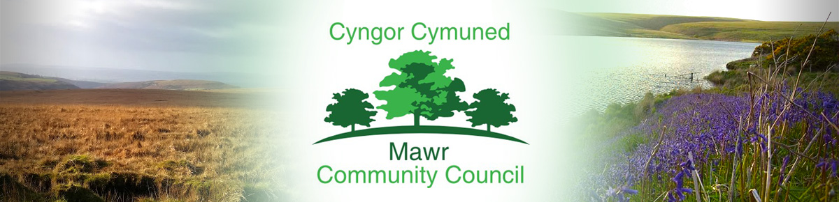
www.mawrcommunitycouncil.org.uk
Ms. M. L. Gabriel – Davies,Clerk / Responsible Financial Officer
C/O Penmount,150 Alexandra Road, Gorseinon, Swansea SA4 4PE
Telephone: 01792 896789 E-mail: clerk.rfo@mawrcommunitycouncil.cymru

Minutes of the Mawr Community Council meeting held via Zoom on Monday 10th January 2022

In attendance: Councillors – T. Roberts (TR), L. Frame (LF), I. Price (IP), J. Hallett (JH), Paul Northcote (PN),
Former Temporary Clerk G. Thomas (GT), Clerk/RFO M. L. Gabriel -Davies (TGD)

- Apologies for absence

Cllr J. Sterio (JS), Cllr B. Rowlands (BR)

- Declarations of Interest

No declarations of interest were recorded.

- Public Forum

There were no matters raised.

- Report on Grants
- TR stated that GWHA has not received the grant money to date. GT to follow up.
- MCC to apply for the CCP Flat Roof leak and Gower Roofing to provide quote. It was agreed that MCC will apply for Mynydd y Gwair Microgrant of up to £1k and the CCP Hall Association will be asked to apply for another grant to cover the repair of all flat roofs of CCP Hall. TGD to look into potential grants.

- Report from County Councillor

BR sent an email about road closure in Garnswllt, installation of Lon Heddwch Park starts next week and the
rubbish collection in Garnswllt and Felindre is delayed by a day.

- Confirm the accuracy of the minutes from the last meeting

Item 14: Chair’s report to be amended to refer to Item 10 and not Item 9.

- Matters arising from the minutes

Specific matters will be dealt with as per the relevant Agenda Item(s)

- Confirmation of Precept requirement - 2022-2023 Budget

GT provided financial reports on MCC Expenditure, Creditor List and Draft 2022-2023 Precept. Confirmation of the precept must be submitted to Swansea City Council by 31 January 202. Some of the budget headings and expenditure do not correlate. GT stated that HSE and OVW consultancy fees need to be included in the precept. GT still contesting the fees being charged by HSE. Swansea Council also sent a letter about budgeting for cost of elections estimated at £2.5k. JH suggested a committee be formed to review the precept.

RESOLVED that TR, LF, GT and TGD will meet to review the budget and spreadsheet to be circulated to the councillors for comments. Zoom meeting to be held on 14 Jan. at 6:00 p.m.
GT to seek clarification from the council about estimated costs of elections.

- Halls update:

Garnswllt Hall / Garnswllt Fields– Cllr T. Roberts (TR) and the temporary clerk (GT)
- Rowan to start work on Garnswllt Hall. RESOLVED that legal insurance will be contacted to get Abacus to fulfil their duty to do the remedial work.
- Biodiversity project in Garnswllt Fields to start on 27 January. Materials for the project were delivered by Dan Snaith and tools currently with TR. Rhys has been asked to help clear the land.
- Recruitment of Project Officer has been delayed. Josh sent a job description but due to UK2 email problems LF has not been able to access the information.

Felindre Welfare Hall – Cllr P Northcote (PN)

Over 40 Selection Boxes were distributed to children with Sue Morgan delivering to families affected by Covid. RESOLVED that PN will provide invoice/receipt for the cost of Selection Boxes be reimbursed to Sue Morgan.

CCP Welfare Hall – Cllr L Frame (LF)

CCP Flat Roof leak has resulted in the damage to the wall.
RESOLVED that MCC and CCP Association will seek grants to repair all the flat roofs of CCP Hall.

- Grass Cutting / Biodiversity within Mawr

RESOLVED that GT and LF will look into next year’s contract.

- Update on GWHA as necessary

GWHA grant has not been received to date.

RESOLVED that GT will ask the grant providers regarding flexibility to go beyond 31 March 2022 in spending the monies.

- Reports from committees, sub committees and working parties

There were no reports.

- Report from the Chairperson

The Chairman did not have any matters to raise, except for the issues that have been outlined under Items 4 and 9 above.

- Clerk’s General Report: Update on matters of relevance.

- Report from the Community Councillors

JH – expressed concern about the bamboo growing near the Memorial Garden. Queried where the recruitment of Project Officer will be advertised. LF responded that it will be advertised on MCC Notice Boards, Swansea Council website, OVW website, Indeed and MCC website.

LF –
- suggested that Rowan be given a key when working in Garnswllt Hall, reminded the council to ensure that it is a construction and therefore, signage and the necessary fencing to keep the place safe be implemented. Hiring of fences could potentially increase costs.
- Raised concerns about on-going problems on drainage and flooding on Clydach Road/ Salem. RESOLVED that these matters will be reported to the County Councillor.
- Issues with UK2 MCC emails. IP, PN and LF having problems accessing MCC email accounts. GT has contacted UK2 and TGD will forward the response from UK 2 to see if the links from UK2 will work.

- Planning Applications

Pre-planning letter received from Cellnex.

RESOLVED to agree with the proposal if it will benefit the community and increase Wi-Fi capacity and connectivity for the area.

- Correspondence

Helen Roberts (HR) asked if Garnswllt Hall can be used as a polling station for the 5 May elections.

RESOLVED that TGD to inform HR the Council agrees that Garnswllt Hall can be used for the election.

- Date and time of next full Council Meeting Monday 21 February at 7pm

Meeting ended 8:53 p.m.

