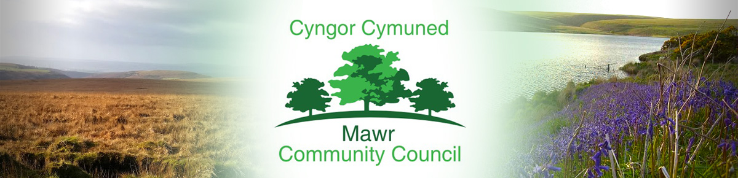 clerk.rfo@mawrcommunitycouncil.cymru Tel. 01792896789
www.mawrcommunitycouncil.org.uk

Minutes of the Mawr Community Council meeting held via Zoom on Monday 21 February 2022

In attendance: Councillors – T. Roberts (TR), L. Frame (LF), I. Price (IP), J. Hallett (JH), Paul Northcote (PN), County Councillor Brigitte Rowlands (BR), Clerk/RFO M. L. Gabriel -Davies (TGD)

- Apologies for absence: Cllr J. Sterio, Former Temporary Clerk G. Thomas (GT)

- Declarations of Interest

No declarations of interest were recorded.

- Public Forum

There were no matters raised.

- Report on Grants – Updates
- Biodiversity project/Swansea RDP – Project Coordinator post recruitment with deadline on 3 March 2022. Raised beds installed, ground prepared for wildflowers and some materials for Garnswllt Fields have been delivered. Awaiting delivery of compost bin, green house and tool shed.
- S. Morgan has been in touch with the outdoor exercise equipment company and will be installed when the weather is better.
- CCP Roof replacement is going ahead and the Hall Committee has decided to have the flat roofs replaced first as they are in worse conditions than the main pitched roof. The pitched roof could potentially cost more as more structural reinforcement may be required. The flat roofs will have rubber roofing which would last for 40 years.
- Explore other avenues of funding: National Lottery Community Fund and new round of MYR grants in April.

- Report from County Councillor Brigitte Rowlands
- Opening of Playground near Lon Heddwch, Craig Cefn Parc was well attended. Council Leader mentioned the £5 million funding available from which the playground was funded and encouraged residents to submit ideas for the use of the funds. The Council thanked BR for the playground. The playground in Rhydypandy has been equipped with equipment and therefore, not eligible for additional funding.
- The Chair (TR) thanked BR for the street lighting on Lon y Felin, Ganrswllt. However, due to the power cut from the storm, the lights are not working. RESOLVED that BR to have Highways check the streetlights.
- The Chair asked about the £5.5 million project of installing solar panels on houses. BR stated that it is called Switched On. RESOLVED that BR will send the information to the council.

- Confirmation of the accuracy of the minutes from the last Council Meeting held on 10 January 2022.

The minutes of the meeting were accepted as a true record. LF confirmed accuracy and seconded by TR.

- Matters Arising from the minutes

Specific matters will be dealt with as per the relevant Agenda Item(s).

- Confirmation of Precept Requirement for 2022/2023

Clerk has submitted the Precept Form to Swansea City Council.

- Halls update:
Garnswllt Hall – Cllr T. Roberts (TR)
- The refurbishment of the hall is on-going. The electricians will soon be finishing the rewiring of the hall. RESOLVED that LF, GT and TGD will check the work once it has been completed.
- The work in the kitchen and the replacement of the ceiling is on-going. RESOLVED that TR, LF, IP, GT and TGD will meet with the builder. The meeting on Friday, 18 Feb. was cancelled due to the storm.
- Quotes for the flooring have been received, however, this needs to be revisited.
RESOLVED that TGD will meet KSC and request a revised quote.
- The roof of the hall is still creating a lot of noise. TGD recorded the noise from the roof. RESOLVED that GT to contact the roofers and TGD to send the video/recording of the noise.

Felindre Welfare Hall – Cllr P Northcote (PN)
- TGD has spoken with S. Morgan (SM) about the replacement of the floodlights and potential for Micro Grant from MYG Micro Grant. However, SM stated that the cost is over £1k so she will try for a bigger grant. TGD informed her about the April round of grants with bigger funding.
- The Sewing Club has started back using the hall.
- SM mentioned about having a defibrillator outside the Hall as a football team will now use the hall and pitch regularly. TGD has contacted NHS Ambulance who suggested obtaining grants to purchase the equipment.
RESOLVED that TGD will liaise with SM and explore grants for the defibrillator.

Craig Cefn Parc Hall
- The work on the replacement of the roof will commence soon and LF has been in contact with the roofers as mentioned. See Update on Grants in Item 4.
- The Hall is now open for parties and bookings
- JH mentioned the condition of the ditches. BR stated that there are other ditches being looked at as well.
RESOLVED that BR will look into the maintenance of the ditches.

- May 2022 Elections and Administrative Issues

RESOLVED that this item will be deferred to the next council meeting in March 2022.

- Reports from committees, sub committees and working parties

There were no reports.

- Report from the Chairperson

The Chairman did not have any matters to raise, except that he feels progress on the Biodiversity Project in Garnswllt is quite slow.

- Clerk’s General Report: Update on matters of relevance.

- Suggested a Newsletter to communicate to the residents about the various developments happening in Mawr.
RESOLVED that TGD will produce a draft newsletter and circulate to the councillors for amendments and
Comments before the next meeting.
- Facebook page of the council needs updating. BR said she has admin rights and therefore, will give TGD admin rights in order to update the page.
RESOLVED that TGD will liaise with BR to obtain the admin rights to the Facebook Page.
- Council Website also needs updating.
RESOLVED that TGD will liaise with GT about the website.

- Report from the Community Councillors

TR – same as Chair’s report above in Item 12.
JH – as mentioned above in Item 9.
LF – Community Garden upkeep and development in connection with RDP. Meet every Tuesday from 10:00 a.m. to 12:30 p.m. Meetings, together with GT and TGD, have been held with Swansea RDP team.
PN – same as above in Item 9.

- Planning Applications
All planning reports from Swansea City Council have been circulated. No observations raised.

- Correspondence
All correspondence received have been circulated to the councillors.

- Date and time of next full Council Meeting Monday 14 March 2022 at 7:00 p.m.

Meeting ended at 8:05 p.m.

