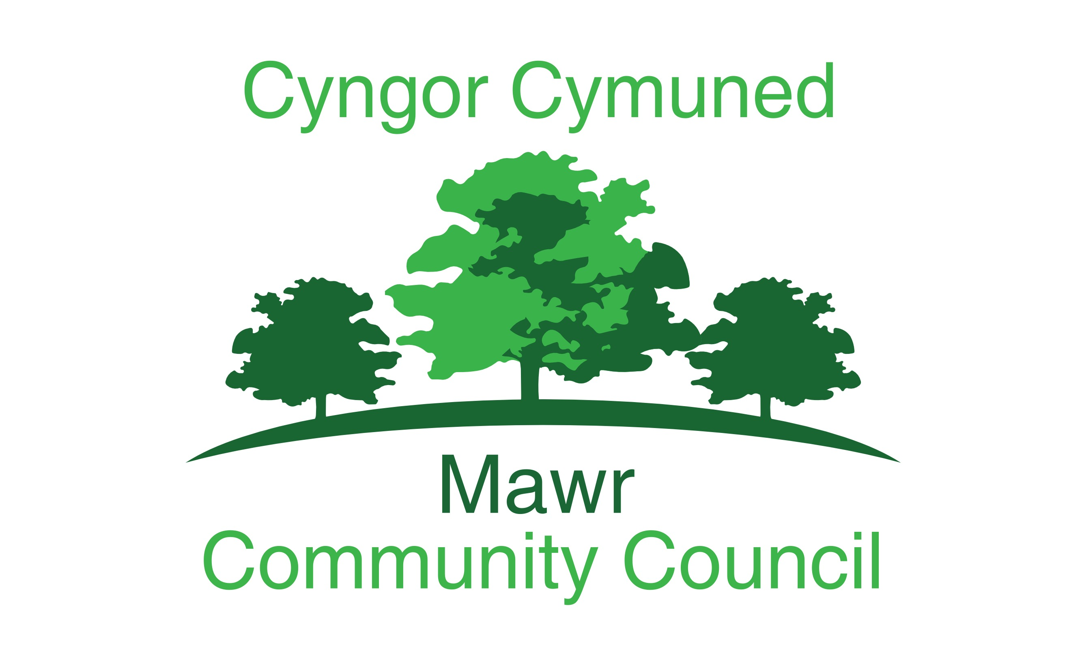

Clerk: Rachel Bull

49 Awel Y Mor, Swansea, SA2 9FL

[clerk@mawrcommunitycouncil.cymru](mailto:clerk@mawrcommunitycouncil.cymru)

www.mawrcommunitycouncil.org.uk

07730 527745

**Minutes of the meeting of the Mawr Community Council held at Felindre Welfare Hall on 27th January 2020 a/t 7pm. For the transaction of the following business:**

**Present:** Chair L Frame, P Northcote, G Morgan, I Price, J Hallet, T Roberts, D Galloni

# APOLOGIES FOR ABSENCE

1/2020

**J Sterio**

1. **TO RECEIVE DECLARATIONS OF INTEREST**

**None**

1. **Reports from the County Councillor**

**2/2020**

The County Councillor was in attendance:

There were 2 dips in the road in Rhydapandy that needed to be mended.

Both schools in Felindre and CCP would be going up for auction shortly.

There is a consultation re the CCS Budget taking place for those that want to have their say.

Woodland Trust - Trees

Field in Garnswllt – Playing Surface

New Notice board in CCP

1. **Public Forum**

**3/2020**

A member of Garnswllt Hall Committee was dissatisfied with the amount of money being spent on Garnswllt Hall compared to Felindre and Craig Cefn Parc. He said urgent repairs we needed in Garnswllt Hall and things had been outstanding for several years. The council commented that none of the issues had been brought to their attention recently and with regards to the improvements to the other two halls these had been arranged by the respective hall committees for each hall.

1. **Confirmation of the accuracy of the minutes**

**4/2020**

**Resolved: Minutes from the last meeting on 9.12.2019 we agreed – All in Favour**

1. **Matters rising from the minutes**

**5/2020**

*Action: County Councillor to contact estates department re school*

*closure to see if any monies could be given to the play ground fund*

*Chase Boiler quotes for CCP*

*Chase Felindre Risk assessment on the damage to the toilet wall*

*Clerk to chase Welsh Water*

*Clerk to write letters of congratulations to both hall committees.*

1. **Precept 20/21**

**6/2020**

Following on from the budget meeting on 9th Dec 2019 the council considered the options for the precept.

**Resolved: That the precept for the 20/21 period is in the sum of**

**£66,000 – 5 in favour with abstentions**

1. **Central Heating Upgrade - CCP**

**7/2020**

Moved to next Agenda

1. **Drainage in CCP**

**8/2020**

Moved to next Agenda

1. **Kites and Dipper Tree Planting in CCP**

**9/2020**

**Resolved: Kites and Dippers will be allowed to plant trees in the CCP field on 14th March 2020 – All in Favour**

1. **Garnswllt Hall Drains**

**10/2020**

Moved to next agenda – clerk awaiting to hear back from Welsh Water investigation.

1. **Benches for CCP**

**11/2020**

Moved to next agenda

*Clerk to Speak to groundsman to see if existing frames can be utilised*

1. **Newsletter**

Councillor Frame gave the clerk updates to make

1. **V.A.T**

**12/2020**

Moved to next Agenda

1. **Garnswllt Hall Exterior Paint**

**13/2020**

**Resolved: That £650.00 be paid to Garnswllt Hall Committee for the exterior painting of the hall – All in Favour**

1. **Youth Club Entry Fee**

**14/2020**

**Resolved: That the entry fee for the clubs should be lowered from £1.50 to £1 per child.**

1. **Reports from Committees, Sub Committees and Working Parties**

**15/2020**

The Community Plan is being finalised.

1. **Report from the Chairperson**

**16/2020**

Cllr Frame:

Friends of CCP – Have asked if they can have a notice board in the park to put updates on re the playground project.

They also asked if bins could be put in the park, this was discussed, but the council would have no-one to empty the bins on a regular basis, therefore the council would not be able to provide bins at this time.

They also would like a shed for the community growing project – Cllr Rowlands kindly offered to check if this would require planning permission or not.

*Action: Clerk to put it on next agenda*

*Cllr Frame to report back re Crowd Funding Commitment*

One Voice Wales:

Bounday Commision report are due in March

Every Community Council needs a bio diversity plan by the end of this year

*Action: Clerk to prepare Bio Diversity Plan and look into fields in trust status*

1. **Report from the Clerk**

**17/2020**

**Resolved: The following book are to be purchased to enable the clerk to complete her studies and as a resource for council:**

**Arnold-Baker – Local Council Administration**

**Local Council Clerks Guide -All in Favour**

1. **Report from the Community Councillors**

**18/2020**

**Cllr Morgan & Cllr Northcote**

Felindre Hall Committee had secured a regular booking with a local football team for use of the field and changing rooms. However the pitch needs to be brought up to spec and goal posts purchased etc so they are looking into grant funding.

*Action: Cllr Northcote and Cllr Morgan to compose letter and collect signatures re Bwlch Gwin lighting and Invite PCSO to next meeting*

***Cllr Roberts***

More speeding down Lon Y Felin, he has been in touch with Go Safe but they need 6 volunteers to utlise the equipment to catch people speeding.

**Cllr Hallet**

More fly tipping seems to be occurring in CCP

1. **To Consider Planning Applications**

**19/2020**

**Re Solar Farm in CCP**

Clerk to respond as follows:

Although a precent has been set there should be a limit of the amount of solar fams in the area, there needs to be a pragmatic approach to enable the farm land to mix in with the solar panels**.**

Also clerk to ask how long the panels will be in situ

1. **Correspondence**

**20/2020**

An email from a resident was read out re the grave stones at Gerazim Chapel – Clerk to contact CCS with concerns that they are being removed unecessarily

1. **Financial Report and Presentation of Payments to be Made**

**21/200**

**Suspend standing orders**

**22/2020**

Financial Reports for January 2020 were reviewed and approved

**Resolved: That the accounts, reconciliation, and payments for January 2020 have been reviewed and approved.**

**Motion carried - All in favour**

1. **Staff Matters**

**None**

1. **Date and Time of Next Meetings**

**23/2020**

**24th February 2020 – Craig Cefn Parc Welfare Hall – 7pm**

**Meeting Closed at 9.45pm**



**Rachel Bull - Clerk**