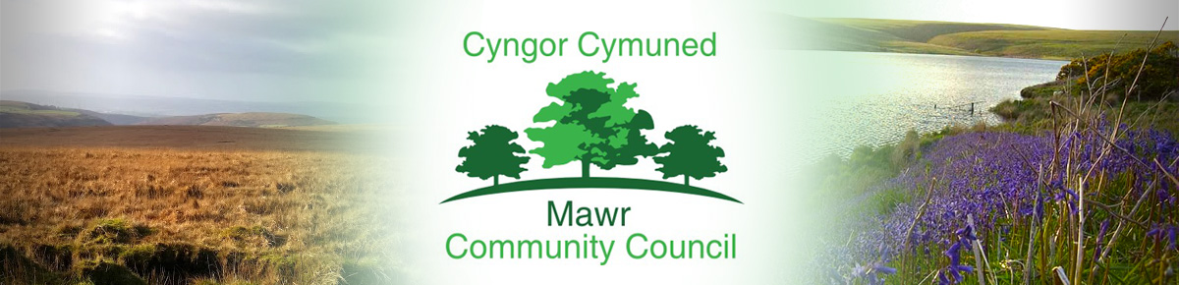

Clerk / Responsible Financial Officer: Ms. M. L. Gabriel – Davies
C/O Penmount,150 Alexandra Road, Gorseinon, Swansea SA4 4PE
Telephone: 07368 652254 E-mail: clerk.rfo@mawrcommunitycouncil.cymru
www.mawrcommunitycouncil.org.uk

Minutes of the Extraordinary Meeting of Mawr Community Council held remotely via Zoom on Monday 6 February 2023 at 7.00pm.

Present: Cllr. Linda Frame (Chair - LF), Cllr. Darren James (DJ), Cllr. Laura Jane Thomas (LJT), Cllr. Martin Davies (MD), Cllr. Caroline Williams (CW), Cllr. Gaynor Price (GP)

Apologies for Absence – None

Declarations of Interest – None

Ratify the appointment of the Clerk/RFO

Following interviews with all four applicants, the Personnel Committee made a recommendation to the Council that Mrs. Susan Rodaway be appointed as the Clerk/RFO to Mawr Community Council.
Proposed: Cllr. DJ; Seconded Cllr. LJT - Agreed Unanimously
Resolved: That Mrs Susan Rodaway be appointed as the Clerk/RFO to Mawr Community Council.

The Personnel Committee also made a recommendation to the Council that Mrs. Susan Rodaway should commence her duties on 15 February 2023 to ensure a smooth transition between her and the outgoing Clerk/RFO.
Proposed: Cllr. CW; Seconded Cllr. MD – Agreed Unanimously
Resolved: That Mrs. Susan Rodaway commences her duties on 15 February 2023 to ensure a smooth transition between her and the outgoing Clerk/RFO.

To consider staff matters relating to an alleged data breach.

Further to a request by the Information Commissioner’s Office (ICO) that Mawr Community Council should investigate an alleged data breach, a comprehensive investigation was conducted by the members of Mawr Community Council during the Extraordinary Meeting. All the available evidence provided by the complainant to the ICO was carefully examined and considered. Members determined that a data breach had not occurred and the Chair should inform the complainant of the Council’s findings by email and by hard copy letter.
The Council also agreed that the Data Officer should inform the ICO of the Council’s findings.
Proposed: Cllr. MD: Seconded Cllr. DJ – Agreed Unanimously
Resolved: That the Chair will inform the complainant by email and hard copy letter of:
The Council’s comprehensive investigation with regard to the alleged data breach;
The Council’s careful consideration of all the available evidence provided by the complainant to the ICO;
The Council’s determination that a data breach has not occurred;
The Council’s Data Officer will confirm the same in an email to the ICO.

The meeting concluded at 8.45pm

Cllr. Linda Frame
Chairperson

